Recommendations for an Accessibility Standard for the Design of Public Spaces for the Minister of Families
October 5, 2020

The Accessibility Advisory Council (Council), in conjunction with the Design of Public Spaces Standard Development Committee (Committee), is pleased to provide the Minister of Families with its recommendations for an Accessibility Standard for the Design of Public Spaces pursuant to Section 9(1) of The Accessibility for Manitobans Act (AMA). This paper identifies the scope and intent of the standard, provides an overview of the process followed by the Council to develop the proposed standard, and sets out initial recommendations for the implementation of an effective standard. The Accessibility Standard for the Design of Public spaces focuses on good planning and design to create an environment that considers human diversity and inclusion.
In March 2019, the Honourable Heather Stefanson, Minister responsible for the AMA, established the Terms of Reference for the Design of Public Spaces Accessibility Standard. The Minister requested that the standard specify requirements to identify, prevent, and remove barriers in the design of exterior public spaces. In this way, the Design of Public Spaces Accessibility Standard aims to address only those areas outside the jurisdiction of The Manitoba Building Code. Enhancement of accessibility through updates to the Manitoba Building Code will take place through a separate process, apart from the work performed in the development of this particular standard.

Social and Legal Framework

The AMA became law in 2013. The purpose of the legislation is to provide a clear and proactive process for the identification, prevention and removal of barriers. Accessibility standards under the AMA are laws that apply to Manitoba businesses and organizations. The AMA identifies five fundamental areas for standard development: customer service, employment, information and communications, transportation and the design of public spaces.
Standards provide a legally binding foundation for practice and enforcement. Standards are in force for accessible building design in the form of the Manitoba Building Code, but the design of accessible exterior environments is governed only by non-binding guidance documents in Manitoba. The enactment of the Design of Public Spaces Standard will therefore fill a significant gap.
The social and legal rationale for the AMA can be summarized as follows:
- Accessibility will improve the health, independence and well-being of persons disabled by barriers.
- Barriers create considerable costs to persons disabled by those barriers, their families and friends, and to communities and the economy.
- In developing our built environment, barriers have been perpetuated.
- A systemic and proactive approach for identifying, preventing and removing barriers complements The Human Rights Code (Manitoba) in ensuring accessibility for Manitobans.
- Under The United Nations Convention on the Rights of Persons with Disabilities, which Canada ratified in 2010, member states are expected to take appropriate measures to ensure accessibility and independent living
- The equality rights of all Canadians, including persons disabled by barriers, are enshrined in the Canadian Charter of Rights and Freedoms.

If we want everyone to participate in public life, we must design and build inclusive public spaces that are accessible to all. Everyone accesses the built environment differently, with abilities changing across a person’s lifespan. With an estimated one in four Manitobans affected by disability, and that number expected to increase in the years ahead, we must design and build public spaces that are accessible to all.
Barriers are often created and perpetuated through a lack of planning or appreciation of the significance these obstacles play in people’s daily lives. A proactive process of developing and updating accessibility standards for public spaces will help designers, developers and administrators to create communities that are more inclusive for all Manitobans, regardless of abilities.

Relationship to the Manitoba Building Code

The Accessibility Standard for the Design of Public Spaces (DOPS) is a companion to the Manitoba Building Code (MBC). Where there is overlap between the MBC and the DOPS Standard (e.g., related to building egress, parking and signage) the DOPS Standard defers to the most current version of the MBC to avoid duplication or contradiction. Updates to the MBC occur through an independent process resting with the Office of the Fire Commissioner.

Scope and Purpose

The proposed Accessibility Standard for the Design of Public Spaces document applies to the process of planning, organization, and construction of the exterior built environment, along with the maintenance of these public spaces (see Definitions). The Standard aims to identify, prevent and remove barriers to public outdoor spaces by providing specific minimum requirements. It is not intended to limit the creativity of the design process during planning, construction and maintenance of public infrastructure.
Whether it be safer streetscapes, a re-thinking of bike lanes, or a broader approach to designing communities for all seasons and for people of all ages and abilities, jurisdictions are being challenged to meet the changing needs of their citizens. Just as there is no shortage of publications advancing the need for greater accessibility in our exterior environments, there currently exists any number of design standards for the exterior environment, including Ontario’s Design of Public Spaces Accessibility Standard. Ontario’s Standard is one of several sources used by the committee to determine the technical requirements of the draft Standard. For a complete list of the source materials used, see Appendix 1.

The Process to Develop a Design of Public Spaces Standard

The Council has the responsibility to make recommendations to the Minister regarding the development of accessibility standards. The Council is composed of up to nine members with diverse backgrounds and experience, including representatives of organizations of persons with disabilities, business, municipalities and other organizations.
Under the AMA, the Council has the authority to establish standard development committees with the expertise required to develop a particular standard. The Council created a Design of Public Spaces Standard Development Committee and selected its members with approval from the Deputy Minister of Families. The Committee, which represents a broad range of interests, met regularly between November 2018 and September 2019. It submitted its initial proposed standard on September 30, 2019, when the Council began its review.
In November 2019, a discussion paper was released to the public setting out the Council’s recommendations. Members of the public were invited to comment on the recommendations through written and oral submissions and through participation in a public consultation and webcast.
On January 15, 2020, the Committee, in conjunction with the Council, hosted a half-day consultation. More than 100 people attended. The consultation was also webcast, allowing individuals unable to attend in person the opportunity to participate. Given the Committee’s expertise in this particular area, the Council requested that it review and consider public comment and submissions. It received many helpful submissions from organizations such as:
- The City of Winnipeg
- The Association of Manitoba Municipalities
- The University of Manitoba
- Manitoba Government Employees Union
- Barrier-Free Manitoba
- Canadian National Institute for the Blind
- Visually Impaired Resource Network
The Committee and the Council sincerely appreciate the wide range of feedback and comments provided by stakeholders and the public. The minimum requirements presented herein represent a consensus of the Committee and have been further refined by public input. The Committee has carefully considered all the responses and has incorporated many of them into its recommendations.

One of the recommendations outside the scope of this particular standard, but of keen interest to the Accessibility Advisory Council and the Design of Public Spaces Standard Development Committee is the issue of funding and availability of government grants as an incentive to address the prevention and removal of barriers. Barriers are not created out of any necessity, but rather because of a lack of planning and appreciation of the significance these obstacles play in the daily life of many individuals.

The cost of incorporating inclusive design into a project from the outset is typically relatively small. The removal of barriers from a constructed physical space to achieve an environment that is accessible to all is considerably more expensive. Thus, increasing accessibility can progress in two ways. With this standard, we will ensure future accessibility within the built environment. However, provinces such as Ontario and Nova Scotia have taken significant steps to increase current accessibility within the built environment, through the provision of grants and subsidies to businesses and municipalities to remove existing barriers and provide increased accessibility within the built external environment. Last year, in Nova Scotia alone, more than $1,000,000 of government grant funding was awarded to help businesses remove barriers and increase public accessibility within the built environment.

From submissions received through the public consultation process, there is a broad and unified voice for creating greater accessibility within our communities, ranging from individuals to municipalities to designers. Attaining the level of accessibility recommended by the proposed design of public spaces requirements is both ambitious and achievable. It will take the effort of all stakeholders to bring about these changes, including government, whose investment is crucial in assisting our collective responsibilities of a more accessible province.

TABLE OF CONTENTS

The Table of Contents is automatically generated. When the template is first opened, page numbers may be incorrect. To update, right click anywhere in the field (shaded area) and select Update Field, Update entire table. When printing, the update prompt may display if any changes have been made since the previous update.
1.1. Intent 1
1.2. General Application 2
1.3. Compliance 3
1.4. Schedule 3
1.5. Transition 4
1.6. Establishment of Policies 4
1.7. Dimensions and Tolerances 4
1.8. Document Format 4
1.9. Acronyms 4
1.10. Definitions 5

SECTION 2 DESIGN REQUIREMENTS
2.1. Accessible Path of Travel 1
2.2. Ramps 9
2.3. Stairs 10
2.4. Mechanical lifts 11
2.5. Pedestrian Crossings 12
2.6. Bike Lanes and Paths 14
2.7. Exterior Parking and Loading zones 22
2.8. Exterior Signage 27
2.9. Controls 32
2.10. Hearing Assistance Systems 33
2.11. Lighting 34
2.12. Counters, Tables and Service Desks 36
2.13. Benches and Seating 37
2.14. Washrooms 38
2.15. Play areas 39
2.16. Sports facilities 43
2.17. Docks / Boat Launches 45
2.18. Beach Routes and Recreational Trails 47

SECTION 3 OPERATIONS
3.1. Maintenance 1
3.2. Snow clearing 1

Appendix 1

  - Intent
    - This standard specifies technical requirements to make the exterior built environment accessible and safely usable by persons with physical, sensory and cognitive disabilities. It describes minimum technical requirements that shall guide the design, construction and maintenance of public spaces, and modifications to existing public spaces.
    - The Design of Public Spaces Accessibility Standard is intended to identify applicable Codes and standards related to public spaces and fill gaps where no Code or standard is in place. It is written to complement the requirements of existing Codes, standards, and bylaws. Where there is compelling evidence, this Standard identifies places where revisions or updates are recommended to those documents.
    - Further to the definition of public space presented herein, this Standard applies to all community spaces, including streetscapes, parks, plazas, public monuments, cemeteries and community gardens. The design and location of exterior elements such as light standards, mailboxes, trash receptacles, planters, tables, kiosks, and transit passenger shelters are also subject to these Standards.
    - This standard is to be read in conjunction with the following source Codes and Standards:
            - Manitoba Building Code M.R. 31/2011
            - Manitoba Fire Code M.R. 155/2011
            - CSA B651-18 Accessible Design for the Built Environment
            - CSA Z614-14 (R2019) Children’s Playspaces and Equipment
            - TAC Geometric Design Guide for Canadian Roads, Chapter 6 and Chapter 8.
            - All Accessibility for Manitobans Act Standards
    - Figures are included for explanatory or illustrative purposes only If there are any differences between the text and the figure (where provided) the text shall take precedence.
  - General Application
    - Requirements of this Standard apply to newly constructed and redeveloped public spaces on or after the dates set out in Paragraph 1.4 Schedule.
    - For redeveloped public spaces, this Standard applies to the parts undergoing alteration. If the alteration will affect the accessibility of the existing public space not altered or repaired, those parts of the existing public space shall be improved as required to bring them into compliance with the Standard.
    - Compliance with the Standard is not triggered by repairs and maintenance activities, or alterations related to temporary environmental mitigation or restoration, such as emergency riverbank restoration.
    - The accessibility standard for the Design of Public Spaces applies to any organization that constructs or redevelops public space. Obligated organizations include:
      - The Government of Manitoba;
      - Public Sector organizations; and
      - Private and non-profit groups responsible for constructing or managing public spaces.
    - Temporary facilities such as construction access routes and seasonal patios are required to comply.
    - Emergency repairs to public spaces and outdoor facilities are not required to meet the Standard. Where such measures are in place for longer that one (1) month, they must be replaced with a solution that is compliant.
    - Exceptions to particular requirements of this Standard are permitted where obligated organizations can demonstrate one or more of the following:
      - that compliance with that requirement would interfere with the cultural heritage value or interest of a property listed in a municipal, provincial or federal heritage registry;
      - that compliance poses a serious risk to the ecological integrity and natural heritage values of the property, directly or indirectly.
      - that it is technically infeasible to comply with the requirement due to existing physical site constraints beyond the control of the obligated organization, such as extreme river level fluctuations or natural terrain.
    - Exceptions permitted under 1.2.7 apply solely to the particular regulation that is excepted, and only for those portions of the site where the obstacle to compliance can be demonstrated.
    - Where compliance with applicable requirements has been demonstrated to be technically infeasible, the new construction or redevelopment shall comply with the requirements to the maximum extent feasible.
  - Compliance
    - Compliance with this Standard will be achieved by:
      - implementing the applicable solutions described in the Section 2 Design Requirements; or
      - using alternative solutions that will meet the Intent listed in Section 2 and achieve or surpass the minimum functional requirements as described in the related subsection.
  - Schedule
Once the Standard comes into force, obligations will be phased in over three years affecting new projects of the Manitoba Government, Public Sector, and all other obligated organizations as follows.

Type | Timeframe
Manitoba Government | After one year
Public Sector Organizations  except small municipalities | After two years
All other organizations | After three years

  - Transition
    - The Standard applies to the design and construction public spaces contracted on or after the date the Standard comes into force. Work resulting from a design and construction contract signed before the date the Standard comes into force is not obliged to comply with the Standard.
  - Establishment of Policies
    - Every obligated organization shall develop policies, practices and procedures to meet the requirements set out in this standard.
    - Policies developed by obligated organizations shall be available to the public upon request.
  - Dimensions and Tolerances
    - Dimensions that are not marked maximum or minimum are absolute, unless otherwise indicated. All dimensions are provided in metric units. Linear dimensions are displayed in millimeters, unless otherwise noted. Where units have been converted from Imperial (feet, pounds, etc.) they are rounded to the closest metric equivalent, typically to the nearest 5 mm, except where tolerances are critical and greater precision is required, such as for grate openings or threshold lips.
  - Document Format
    - This document has been formatted to facilitate public review. Each of the sections includes its own intent statement, applications, exclusions, and design requirements. Within the design requirements, Design Notes have been included that are not regulatory, but help provide context and guidance on the application of the standard and other considerations. To differentiate them from regulatory standards, Design Notes are set in bordered text boxes. Defined terms are shown in italics.
  - Acronyms
    - The following acronyms are used in this document:
AODA – Accessibility for Ontarians with Disabilities Act
CNIB – Canadian National Institute for the Blind
CSA – Canadian Standards Association
DOPS Standard – Accessibility Standards for the Design of Public Spaces
MBC – Manitoba Building Code
NBC – National Building Code of Canada
TAC – Transportation Association of Canada
  - Definitions
    - Accessible Path of Travel – an outdoor sidewalk pathway or similar that enables persons of all abilities to access their intended destination.
    - Boat slip – the portion of a pier, main pier, finger pier, or float where a boat is berthed or moored, or used for embarking or disembarking.
    - Composite play structure – playground equipment that is attached through elevated decks, climbers or ground level pods to create one integrated play unit.
    - Colour Rendering Index – a measure of the ability for a light source to reveal colours faithfully, in comparison with a reference source, often sunlight.
    - Cross slope – the slope measured perpendicular to the typical path of travel.
    - Curb ramp – is a graded transition between the sidewalk and the street, linking the sidewalk seamlessly with the pedestrian crossing that It serves.
    - Cultural heritage value – attribute of a site that may limit physical intervention, including accessibility upgrades. In order to demonstrate cultural heritage value, sites must be publicly listed as part of a cultural, natural, or heritage site registry, including those designated as National Historic Sites (Canada) and UNESCO World Heritage Sites, or otherwise protected under the Manitoba Heritage Resources Act or Historic Sites and Monuments Act (Canada).
    - Edge Protection – a raised barrier along an accessible path of travel.
    - Elevated Deck – a portion of a composite play structure in which there are level surfaces above grade. These level surfaces (decks) can be accessed by stairs, ramps, or climbers.
    - Elevated Play Component – play component that in order to fully use the component, must be accessed off elevated decks in a composite play structure, examples include climbers that lead from an elevated deck to the ground surface, slides, or fireman poles.
    - Facility access point – location at which one gains entrance to the primary area of activity and/or the general assembly or foyer space within a built structure.
    - Gangway – a variable-sloped pedestrian walkway linking a fixed structure or land with a floating structure.
    - Ground Level Play Component – components that can be utilized off the ground level, such as spring riders, play panels at grade, etc.
    - Heavily patterned – a pattern where there are multiple changes in contrast within a 300 mm x 300 mm square that can have a visual affect creating dizziness or imbalance.
    - Hearing Assistance System – devices that can be integrated into an environment to amplify select signals that are receivable by people using hearing aids.
    - Illumination – light intensity, as measured in lux.
    - Level – applies to a surface that has less than 2% slope in all directions.
    - Light distribution – the pattern of light on a surface. Manufacturers offer different distribution patterns for different applications – for example sidewalks might use the long narrow Type I distribution, while parking areas benefit from the square Type VS.
    - Maintenance – activities that are intended to keep existing public spaces in good working order. Maintenance can also include the restoration of deteriorated spaces or elements back to their original condition. Maintenance work could include painting or minor repairs.
    - Natural heritage values – the significance a site’s natural assets and their sensitivity to physical intervention, including accessibility upgrades. Assets include water, fish, wildlife, plants, invertebrates, species at risk, and ecological integrity.
    - Obligated organization – bodies required to comply with the requirements of the DOPS Standard.
    - Play Component – an element within a play area that can be used for play, learning, socializing, etc. Decks, ramps, transfer systems and stairs are not considered play components but means of access to them.
    - Prevailing construction practices – those methods typically used by local contractors and designers when faced with the same or similar design conditions.
    - Public space – all exterior spaces that are open to public use including rights-of-way, publicly-owned land and publicly accessible privately-owned land (i.e. parking lots and plazas). Public spaces covered by this standard include, but are not limited to:
- Pedestrian routes and signal systems
- Parking areas
- Trails and beach access routes
- Outdoor plazas and public eating areas
- Public courtyards
- Outdoor parks, play structures, and other community spaces
    - Push ramp / runnel – an auxiliary sloped surface adjacent to a set of stairs in an exterior path of travel that has the same rise and run as the adjacent stairs, has a narrow width, and is solely dedicated to the movement of unoccupied wheeled devices as an alternative to transitioning the actual stairs with the device.
    - Ramp – an accessible path of travel that has an incline greater than 1:20.
    - Recreational Trail – a path of travel that is intended for active use through a wilderness location and/or for a specific mode of transport, and its design is guided by the optimization of both the natural environment and the intended active use.
    - Redevelopment – significant planned alterations to a public space other than repairs. Generally these alterations include enlargement, additional facilities, relocation, or change of use.
    - Repair – The reconstruction or renewal of any part of an existing public space for the purpose of its maintenance or to correct damage.
    - Running slope – the slope measured parallel to the typical path of travel also known as longitudinal slope.
    - Sport Facility – that portion of a space where the play or practice of a sport occurs as per the governing body responsible for that sport, and/or the design criteria placed on the safe and active use of a space for the designated sport.
    - Surfacing (for play areas) – the ground surface beneath the play equipment. Engineered wood fibre (a loose fill surfacing) is currently considered a minimally accessible surface but is quite difficult to wheel on for wheelchair users and those with mobility issues. Unitary surfacing (such as poured-in-place rubber) provides a much more user-friendly means of access for all users
    - Tactile Walking Surface Indicators (TWSI) – standardized walking surfaces that convey information to people impacted by blindness through texture and, occasionally, sound. Also known as detectable warning surfaces or tactile attention indicators. Typical TWSI applications are for attention or guidance. Refer to Clearing Our Path for design requirements: http://www.clearingourpath.ca/3.3.0-twsi_e.php
    - Technically infeasible – where existing physical or site constraints prohibit construction, modification or addition of necessary elements to fully comply with the requirements of the Standard.
    - Temporary Facilities – a facility that is not of permanent construction but that is extensively used or is essential for public use for a period of time. Examples include, but are not limited to, bleacher areas, ‘pop-up’ kiosks, pedestrian access routes at construction sites, and temporary art installations. Structures and equipment for the exclusive use of construction crews such as scaffolding, bridging, materials hoists, or construction trailers are not included under this Standard.
    - Transfer System – platform located at a certain height above the ground in which people in wheelchairs can transfer from their wheelchair to the play structure or play component.
    - Transition plates – are sloping pedestrian walking surfaces located at the end of a gangway.
    - Unexpected drop off edge – a drop of more than 200 mm not generally anticipated within the context of the surrounding environment.

- Design Requirements
  - Accessible Path of Travel
    - Intent
The accessible path of travel is critical to all aspects of the design of public spaces. Ensuring access to both the functional and experiential components of the public realm is a priority that must be addressed in a manner that provides equal access while maintaining the contextual integrity of the spaces being considered.
    - Source Standards
      - City of Winnipeg Accessibility Design Standard
      - Supplemental guidance: AODA Design of Public Spaces Accessibility Standard
    - Related Sections
      - All sections of this Design of Public Spaces Standard shall consider this section.
    - Application
The accessible path of travel requirements apply to the development of all pedestrian routes within the public realm that enable all persons to access their intended destination.
An accessible path of travel may include level walking surfaces, sloped surfaces, and ramps.
It is imperative that any additional elements added to the public realm, of a temporary or permanent nature, do not obstruct the accessible path of travel. Such elements may include, but are not limited to:
            - seasonal commercial patios
            - construction scaffolding/ barricades
            - signage
            - trees
            - site furniture (e.g. planters, seating, bike racks)
    - Exceptions
Where an accessible path of travel is subject to exception, the following should be incorporated:
            - level landings within and adjacent to the recreational trail or walkway that:
are wide and long enough to allow users to rest out of the path of travel;
are spaced a maximum of 30 metres apart where the grade exceeds 5%; and
provide a firm, stable slip resistant surface.
            - Appropriate signage per Section 2.8.
    - Design
Except as provided in 2.1.6.2 and 2.1.6.5, an accessible path of travel must have a minimum clear width 1500 mm.
Alternative:
A path of travel may be 1200 mm wide where physical space does not allow for 1500 mm width and there are unobstructed passing spaces of not less than 1830 mm wide by 1830 mm long, located not more than 30 meters apart provided.
All viewing areas, overlooks, or “points of interest’ adjacent to an accessible path of travel shall incorporate, an 1830 mm wide by 1830 mm long level area to allow others to freely move past.
An accessible path of travel must have a minimum 2500 mm headroom clearance height.
Ensuring the accessible path of travel remains at minimum 1500 m width, side intrusions into the path of travel may be up to 100 mm in depth. Any intrusion into the accessible path of travel over 100 mm in depth to a maximum of 300 mm must be delineated at ground level with a detectable warning surface of minimum 300 mm width around the intrusion. Bottom elevation of intrusions must be no more than 680 mm above the ground surface.
Accessible paths of travel shall have a firm stable surface that will reasonably withstand exposure to typical weather conditions for the particular site. The accessible path of travel shall include hard surface materials such as asphalt, concrete, pavers, lumber, or highly compacted fine granular material.

Design Note:
Loose materials such as large crushed rock, natural wood chips and irregular materials such as cobblestones are not considered accessible materials and must be avoided within the accessible path of travel.
Openings within the surface of an accessible path of travel shall
            - have no openings that will permit the passage of a sphere more than 13 mm in diameter, and
            - have any elongated openings oriented approximately perpendicular to the direction of travel.
Except as provided in 2.1.5.8 (a) the maximum running slope of an accessible path of travel shall be 1:20 (5%). An accessible path of travel with a running slope greater than this shall be treated as a ramp as per Section 2.2 Ramps .
            - A change in elevation less than 200 mm along an accessible path of travel (approximately the height of a step) shall not be considered a ramp, if designed so:
any abrupt changes in elevation not more than 13 mm shall be bevelled and have a maximum running slope of 1:2 (50%),
any abrupt changes in elevation more than 13 mm and less than 200 mm have a running slope no less than 1:12 (8.3%).
The maximum cross slope of an accessible path of travel shall be 1 in 50 (2%).
Any stairs within or adjacent to an exterior accessible path of travel shall comply with Section 2.3 Stairs.
A tactile walking surface indicator (TWSI) shall be used within the accessible path of travel where:
            - there is a change in elevation such as a stair, see Section 2.3 Stairs for further details of placement.
            - at back of curb where an accessible path of travel meets a roadway where the vehicle has the right of way.
An accessible path of travel that intersects with a vehicular intersection shall install an Attention tactile walking surface indicator (TWSI). The installation shall meet the CSA and AMA requirements, and shall be to the following specifications.
            - TWSI's shall be colour contrasting to the surrounding surface with the preferred colour being safety yellow.
            - Attention TWSIs shall be provided across the entire width of a curb ramp or depressed curb (exclusive of flares). They should be set back 150 – 200 mm from the curb’s edge and extend 600 – 650 mm in the direction of travel. (www.clearingourpath.ca)
            - A tactile walking surface indicator shall be installed in the following locations: platform edges and unprotected edges with a drop-off greater than 250 mm in height. The TWSI shall run the full length of all unprotected platform edges that border the drop-off.

Design Note:
Guidance TWSIs consist of a pattern of parallel, flat-topped, elongated bars that extend in the direction of travel. Installations can include transit stops, rapid transit platforms and large open spaces. Adapted from www.clearingourspace.ca Reference www.clearingourpath.ca for design specifications and consult with community stakeholders to assist in determining most effective and appropriate installation.
Except at stairs, performance platforms, loading docks, and sidewalks adjacent to roadways and parking lots, where an unexpected drop off edge is created that exceeds 75 mm above an adjacent surface and the drop-off is within 600 mm of the accessible path of travel, then edge protection shall be provide by a continuous curb at least 75 mm high; or; a guard in compliance with MBC.
Where edge protection is provided it must allow for proper drainage in order to prevent the accumulation of ice and water.
The walking surfaces of ramps, landings and treads within an accessible path of travel shall have a finish that is slip-resistant.
All accessible paths of travel shall produce minimal glare and not be heavily patterned.
An accessible path of travel that is shared with other users, such as cyclists, in-line skaters, etc. must be at minimum 2.4 m wide and shall include signage in compliance with Section 2.8 Signage that:
            - designates the shared uses of the path; and
            - indicates cyclists must alert people they are approaching toward or behind them.
Design Note:
The following should be considered when designing accessible paths of travel:
- Informational signage be provided to assist people moving through the area to clearly understand the terrain and amenities complying with Section 2.8.
- Wayfinding strategies (directional signage) be provided to assist people moving through the area to clearly understand how to manoeuvre through the space safely, effectively and equitably. Signage shall comply with Section 2.8.

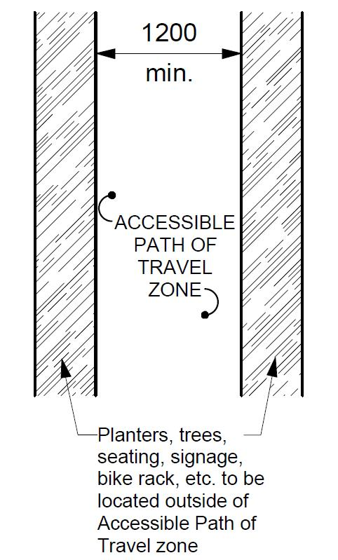
Figure 2.1.5.1 from CSA
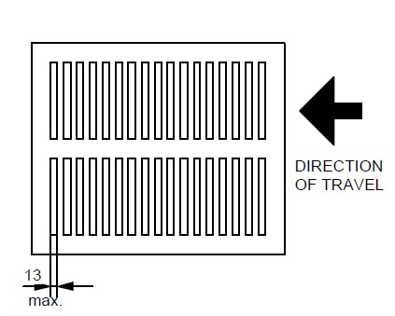
Figure 2.1.5.6 Openings from CSA
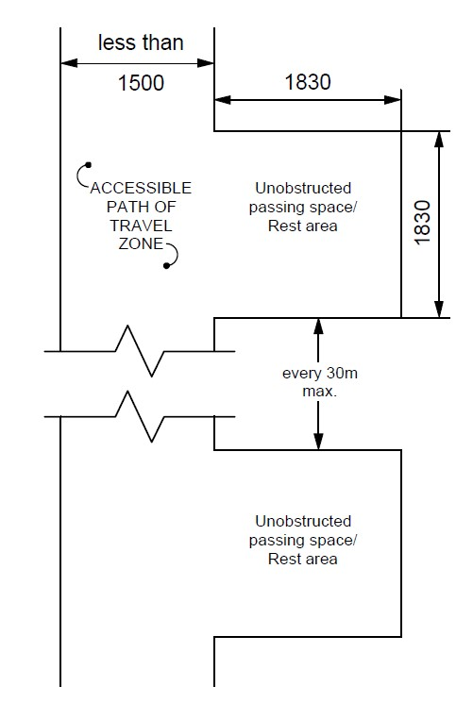
Figure 2.1.6.2 Passing Space Rest Area for Accessible Path of Travel from CSA

  - Ramps
    - Intent
Ramps are intended to provide access to both the functional and experiential components of the public realm where a grade change is required. A ramp must be addressed in a manner that provides equal access.
Source Standards:
(a) City of Winnipeg Accessibility Design Standards
    - Related Sections
      - 2.1. Accessible path of travel
      - 2.3. Stairs
      - 2.4. Mechanical lifts
      - 2.5. Pedestrian Crossings
      - 2.7. Exterior parking and loading zones
      - 2.8. Signage
      - 2.15. Play areas
      - 2.16. Sports facilities
      - 2.17. Docks / Boat Launches
    - Application
This section shall apply to any grade change above the allowable longitudinal slope of an accessible path of travel. Access to all ramps must adhere to accessible paths of travel standard.
    - Design
All ramps within an accessible path of travel shall comply with MBC.
            - A ramp shall be designed with a running slope between 1:15 (6.67%) and 1:20 (5%). A running slope of 1:12 (8.3%) shall be acceptable only in situations where it is not physically practical to achieve a slope of 1:15.
            - A ramp located within an accessible path of travel shall have a clear width not less than 900 mm between handrails or between the inside of the guard(s).
A ramp within an accessible path of travel shall not be curved.
Design Notes:
Ramps that surmount a major change in level (vertical rise) have to be very long and require multiple ramp and landing combinations. In such circumstances, other design solutions should be considered.
Slopes of 1:15 should be used for outdoor spaces due to slipperiness of surfaces.
Width of ramps should be increased to allow for wider wheelchairs, three wheeled bicycles where space allows.
All ramp landings shall have a colour and texture contrast to demarcate the edge of the landing located on a level surface, spanning the full width of the ramp. This shall be located at the edge of the top landing immediately before the sloped portion of the ramp and at the bottom landing immediately after the sloped portion of the ramp.
  - Stairs
    - Intent
Stairs are intended to provide access to both the functional and experiential components of the public realm where a grade change is required. Stairs must be addressed in combination with accessibility for those using wheel-based mobility support.
    - Source Standards:
      - City of Winnipeg Accessibility Design Standards
    - Related Sections
      - 2.1. Accessible path of travel
      - 2.2. Ramps
      - 2.4. Mechanical lifts
      - 2.5. Pedestrian Crossings
      - 2.7. Exterior parking and loading zones
      - 2.8. Signage
      - 2.15. Play areas
      - 2.16. Sports facilities
      - 2.17. Docks / Boat Launches
    - Design
Stairs within or adjacent to an accessible path of travel shall comply with MBC.
Where the natural terrain limits the ability to comply with the rise / tread ratio of the MBC:
            - a consistent tread length and rise height shall be applied where the rise height is no less than 75 mm, and no greater than 180 mm and a tread length is no less than 300 mm, and no greater than 600 mm.
            - requirements for handrails as per MBC, must still apply.
Stairs within an accessible path of travel shall not have open risers.
All landings and stair treads shall have a colour and texture contrast to demarcate the leading edge of the tread or the nosing.
A colour contrasting tactile walking surface indicator (TWSI) surface shall be located at the top of any stairs within, or adjacent to an accessible path of travel. The tactile walking surface indicator shall be located at the top of the set of stairs as well as on landings. It shall be the entire width of the stair and placed one tread depth back from the edge of stair (300 mm) and shall be minimum 610 mm in depth.
Push ramps/ runnels may be incorporated into a stair. If so, they shall be a minimum of 100 mm to a maximum of 250 mm in width. When installed adjacent to a handrail, they shall be located 300 mm from the outside edge of the push ramp to the handrail, ensuring that the maximum space taken up by the push ramp is 300 mm from handrail.
  - Mechanical lifts
    - Intent
Mechanical lifts are intended to provide access to both the functional and experiential components of the public realm where a substantial grade change is required. A mechanical lift must be addressed in a manner that provides equal access while maintaining the contextual integrity of the spaces being considered and safeguarding against risk of accidents associated with the operation of such equipment.
Source Standards:
(a) Canadian Standards Association (CSA) CSA – B535 Lifts for Persons with Physical Disabilities
(b) Appendix E of American Standard of Mechanical Engineers (ASME)
    - Related Sections
      - 2.1 Accessible Path of Travel
      - 2.2 Ramps
      - 2.8 Signage
      - 2.9 Controls
      - 2.11 Lighting
    - Application
A platform lift may be used as a part of an accessible exterior path of travel in lieu of an elevator or ramp where it is technically not feasible to accommodate the requirements of 2.2 for a ramp.
    - Design
The staging area outside of the mechanical lift must allow for sufficient space for individuals to be waiting for use without impeding the accessible path of travel.
A mechanical lift provided as a passenger elevating device as a part of the exterior accessible path of travel shall conform to the latest edition of CAN/CSA-B355. “Lifts for Persons with Physical Disabilities” or Appendix E of ASME A17.1/CSA-B44 (for an accessible elevator).
  - Pedestrian Crossings
    - Intent
Design of the interface between motor vehicles and pedestrians of all abilities requires thoughtful consideration of safety, circulation patterns, movement habits and equal access. Pedestrian Crossings are intended to provide safe harbour, ease of movement and limit exposure to conflicting traffic where the pedestrian realm meets a vehicular right of way or other intended vehicular path of travel. Pedestrian crossings and intersections with pedestrian access must be addressed in a manner that provides equal access while ensuring pedestrian safety.
Source Standards:
(a) Transportation Association of Canada (TAC) Geometric Design Guide for Canadian Roads, Chapter 6 – Pedestrian Integrated Design
2.5.1.3 Supplemented with additional guidance from CSA-B651 Accessible Design for the Built Environment
    - Related Sections
      - 2.1 Accessible path of travel
      - 2.2 Ramps
      - 2.4 Mechanical lifts
      - 2.6 Bike Lanes and Paths
      - 2.7 Exterior Parking and Loading
      - 2.8 Signage
      - 2.9 Controls
      - 2.11 Lighting
    - Application
The requirements for pedestrian crossings apply to all roadways accessible to the public where pedestrian facilities are provided.
Access to pedestrian crossings must adhere to the accessible paths of travel standard.
Design
Pedestrian crossings shall be in conformance with the TAC Geometric Design Guide for Canadian Roads Chapter 6 – Pedestrian Integrated Design.
In addition to conforming with TAC Geometric Design Guide for Canadian Roads Chapter 6 – Pedestrian Integrated Design, the following supplemental requirements apply:
            - Provide a dedicated curb ramp for each direction of travel including all components and in conformance with all requirements provided as design guidance in TAC Geometric Design Guide for Canadian Roads Chapter 6 – Pedestrian Integrated Design.
Design Note:
The spacing between ramps on a corner requires specific grading design where they are close together as the flares on the ramps overlap. The curb height may need to be lowered to reduce damage by vehicles and snow clearing.
            - TWSI’s shall also be provided at medians, refuge islands or other interruptions to the path of crossing including where a second pedestrian activated signal may be provided.
            - Pedestrian crossings shall be perpendicular to the vehicle route being crossed, as much as practicable.
            - Pedestrian crossings shall clearly indicate where crossing should occur.
            - Pedestrian crossings shall be free of obstructions and allow pedestrians to see and be seen by traffic while waiting to cross and while crossing.
            - Pedestrian crossings shall have corner radii designed to ensure vehicles do not drive over the pedestrian area.
            - Accessible Pedestrian Signals be provided.

Design Note
The following should be considered when designing pedestrian crossings:
- A raised pedestrian crossing may be considered first where it does not impede emergency or transit operations. The raised crossing must maintain an elevation difference from the sidewalk detectable to those with visual impairments and meet all curb ramp requirements.
- Crossing distances at intersections should be minimized (consider curb extensions, smaller corner radii, median refuge islands, fewer travel lanes, and narrower travel lanes).
- Be made available at appropriate intervals which match the pedestrian demand to cross the roadway.
- Where signage is required based on TAC compliance, it should meet the intent of (Signage) Section wherever possible and when it is not in contradiction of TAC.

  - Bike Lanes and Paths
    - Intent
These standards provide guidance for integrating hand-cycle, racing chair and other wheeled mobility devices into the design considerations for all exterior paths of travel intended for use by bicycles.
Source Standards:
(a) Transportation Association of Canada (TAC) Geometric Design Guide for Canadian Roads, Chapter 5, Bicycle Integrated Design
2.6.1.3 Supplemented with additional guidance from CSA-B651 Accessible Design for the Built Environment
    - Related Sections
      - 2.1 Accessible path of travel
      - 2.2 Ramps
      - 2.8 Signage
    - Application
These standards apply to multi-use and active transportation paths, and bicycle paths considered within roadway geometric design, including roadways and intersections.
    - Design
An exterior accessible path of travel that is shared with other users, such as cyclists, in-line skaters, etc., shall conform with Transportation Association of Canada (TAC) Geometric Design Guide for Canadian Roads Chapter 5 – Bicycle Integrated Design, with the additional consideration that these standards do not reflect the operating space / dimensions specific to hand-cycles and racing chairs, and the associated increased minimum turning radii and shall be increased where feasible.
Design Note:
The following revisions are recommended:
            - transitions between bike lanes and bike paths require a minimum clear opening of 4 m (cross-ref minimum ramp width in Figure 5.6.5 TAC p 50), and;
            - minimum tapers at bend-in and bend-out configurations for multi-use paths should be increased from 1:3 to 1:5
            - minimum widths of openings of On-Ramps and Off-Ramps should be 4 m (cross-ref Figure 5.6.17 TAC p 63)
            - minimum radii and depths of turns at bikeway crossings at high-speed on/off ramps should be at least 6 m (cross-ref Figure 5.6.18 TAC p 65)
            - minimum openings of bike ramps (TAC 5.7.3) should be at least 4.5 m (cross-ref Figure 5.7.1 TAC p 70)
            - minimum openings between contiguous delineators for transitions between protected bike lanes should be at least 4.5 m (cross-ref Figure 5.7.1 and 5.7.4 and not specified TAC p 70 – 77)
            - signage complying with Section 2.8 be provided indicating the level of accessibility of the path or lane and alternate accessible routes if applicable.

Figures from TAC:

  - Exterior Parking and Loading zones
    - Intent
Location and design of exterior parking and loading zones for persons with physical disabilities are intended to provide accessible access and egress from vehicles, connecting to an accessible path of travel, during all seasons, from the parking space to the public space, building, or facility.
Source Standards:
(a) Manitoba Building Code (2011)
(b) City of Winnipeg Accessibility Design Standards
(c) AODA Design of Public Spaces Accessibility Design
2.7.1.3 Supplemented by TAC Geometric Design of Canadian Roads
    - Related Sections
      - 2.1 Accessible Path of Travel
      - 2.8 Signage
    - Application
Exterior parking and loading will apply to both on street and off-street facilities.
The requirements for accessible on street parking and loading apply all parking designed along a roadway.
The requirements for accessible off street parking and loading apply to all exterior parking areas for public or private parking areas.
    - Exceptions
Where the by-law for the local municipality has requirements that require specific dimensions or quantities that exceed this standard, those standards shall apply.
    - Design
On Street Parking and Loading
            - Location of on street parking shall be determined by need for access.

Design Note
Accessible on street parking stalls should be designed to be within 60 m of the access point for a major attraction or have a minimum of 1 stall every 120 m along a roadway where street parking is provided.
            - Where passenger loading is provided, accessible loading zones shall be designed contiguous with standard passenger loading zones.
            - Passenger loading zones shall have a curb ramp within the loading zone and be adjacent to the accessible path of travel.
            - Parallel on street parking and loading stalls shall be a minimum of 2.7 m wide and 7.0 m long with a curb ramp access at the front or back of the space. Where more than one space is provided the ramps can be combined.
            - The sidewalk area beside parking and loading spaces is to be clear of impediments such as light poles, fire hydrants, planters, and site furniture.
            - All on street parking shall be signed with TAC standard signage RB71 with appropriate arrows.
            - All on street loading shall be signed with TAC standard signage RB72 with appropriate arrows.

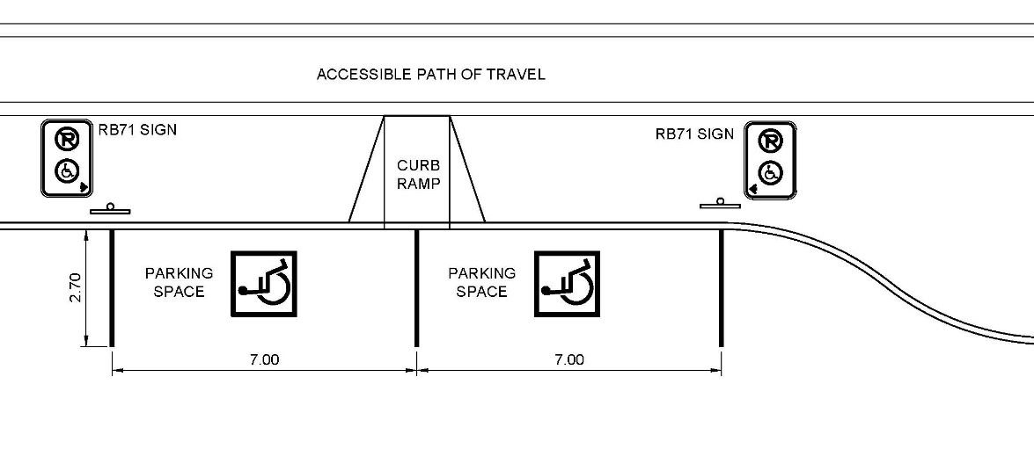
Figure 2.7.5.1a – On Street Parking

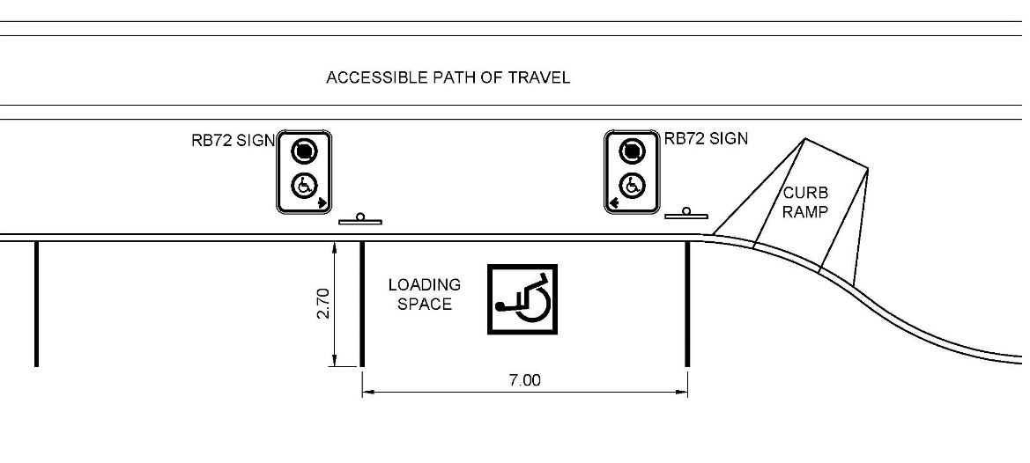
Figure 2.7.5.1b – On Street Loading

Off Street Parking and Loading
            - Accessible off-street parking stalls shall be designed to be within 60 m of the access point to the associated building or facility.
            - Parking to be within 15 m of the accessible path of travel to the building or facility access point.
Design Note:
Consider planning accessible parking directly connected to the accessible path of travel leading the building or facility entrance to allow for protected access.
            - Accessible off-street parking stalls shall be a minimum of 3.05 m wide unless the stall includes an unobstructed access aisle.
            - Parking stalls with an unobstructed access aisle may be 2.45 m wide with an aisle 2.45 m wide.
Design Note:
This type of stall is also known as a Van Accessible stall. The access aisle may be used by two stalls.
            - The number of off street accessible stalls will be as per local zoning bylaw or, where not provided by local by-law, at a minimum as follows:

Total Parking Required | Minimum Number of Accessible Stalls Required | Minimum number of Van Accessible Stalls Required
1 to 25 | 1 | 0
26 to 50 | 2 | 1
51 to 75 | 3 | 1
76 to 100 | 4 | 2
101 to 500 | 4% | 2
501 to 1000 | 2% | 4
over 1000 | 20 plus 1 for each 100 over 1000 | 4 plus 1 for each 100 over 1000

            - Off street accessible loading is to be a minimum of 3.65 m wide and 8 m long to allow for multi-passenger vehicle access.
            - Loading areas are to be adjacent to the accessible path of travel with a level, unobstructed passenger loading area beside the vehicle.
            - All off street parking shall be signed with TAC standard signage RB71 with appropriate arrows.
            - All off street loading shall be signed with TAC standard signage RB72 with appropriate arrows.
            - Include fine amount as per the local municipalities by-laws.
            - Be mounted minimum 1.8 m above the parking surface for visibility.
            - All off street parking and loading on a paved surface are to have a painted pavement marking of an international symbol of access painted in a 1.2 m x 1.2 m square with white figure and border on a blue background.
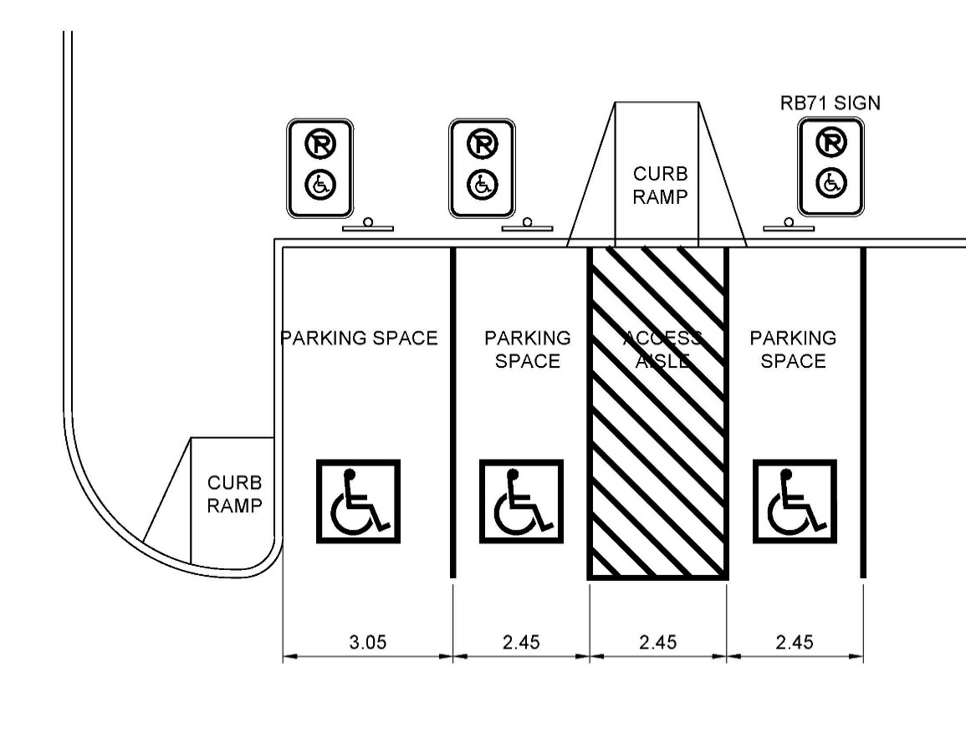
Figure 2.7.5.2a – Off Street Parking

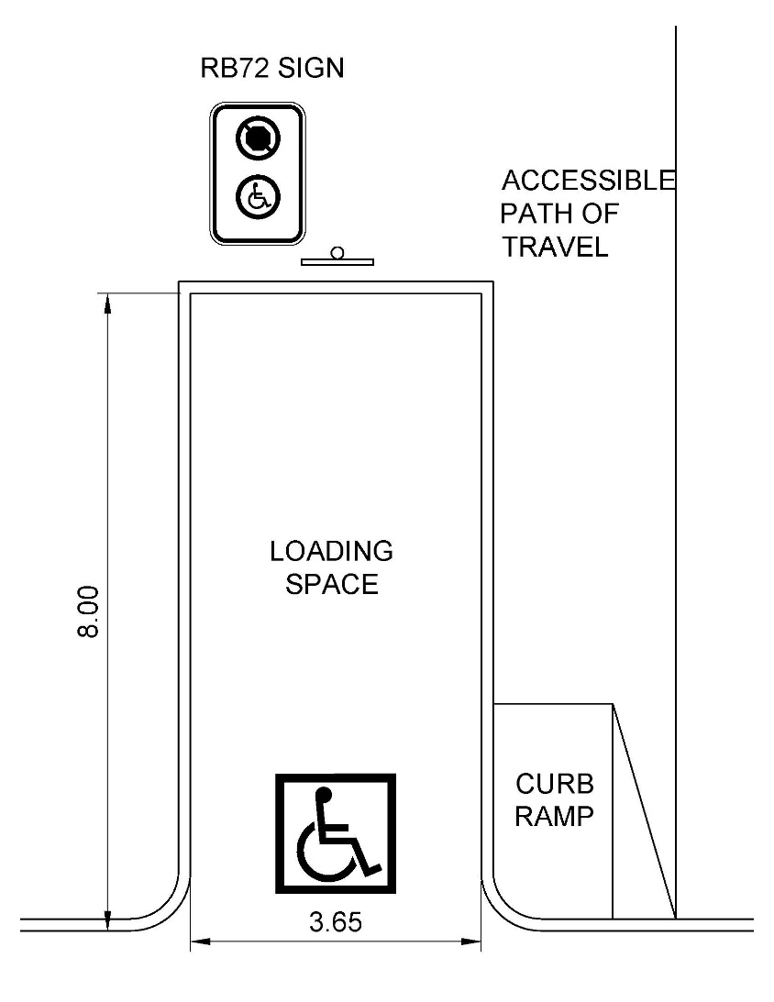
Figure 2.7.5.2b – Off Street Loading

  - Exterior Signage
    - Intent
To ensure that signs providing information and wayfinding strategies within exterior public spaces are located and designed to be understandable to people with physical, sensory and cognitive disabilities, and comply with the AMA Customer Service Standard.
    - Source Standards:
      - CSA-B651 Accessible Design for the Built Environment
      - Manitoba Building Code (2011)
      - Additional guidance: the Accessibility for Ontarians with Disabilities Act (AODA) Design of Public Spaces Standard and the Smithsonian Guidelines for Accessible Exhibit Design.
    - Related Sections
      - 2.1 Accessible Path of Travel
      - 2.2 Ramps
      - 2.4 Mechanical Lifts
      - 2.4 Parking
      - 2.5 Pedestrian Crossings
      - 2.6 Bike Lanes and Paths
      - 2. Exterior Parking and Loading Zones
      - 2.15 Play Areas
    - Application
This standard shall apply to the following:
Directional and Information Signs - Signs that provide direction or information about facilities on the site.
Interpretive and commemorative signs shall meet the requirements of 2.8.6.10.
Means of Egress - Signs on the exterior side of exit doors, and signs providing instructions in areas of refuge as defined in the MBC.
Parking - Accessible Parking spaces shall be identified by signs complying with Section 2.7.
Entrances - All accessible entrances shall be identified by the International Symbol of Accessibility.
Exterior Mechanical Lifts -, Where an accessible lift is provided, it shall be clearly identified with the International Symbol of Accessibility.
Accessible Public Washrooms - Signs shall include the International Symbol of Accessibility.
Beaches, Trails and Wilderness Areas - Provide accessible trailhead signs, located at the entry point to the facility.
    - Exceptions
The requirements of this section do not apply to the following:
            - Building addresses
            - Company names and logos
    - Design
Where signage, including electronic displays, is provided, it shall be:
            - consistently located; and
            - positioned to avoid shadow areas and glare.
            - have a glare-free surface;
            - be of uniform design;
            - when used to give the same type of information within the same facility, be consistently shaped, coloured, and positioned; and
            - be colour-contrasted with its background.
On signs, letters and numerals shall:
            - be in a font selected for legibility (see Design Note below);
            - have Arabic numbers;
            - have a width-to-height ratio between 3:5 and 1:1;
            - have a stroke-width-to-height ratio between 1:5 and 1:10;
            - be colour-contrasted by at least 70% with its background, with light lettering on dark providing the greatest legibility;
            - have the character height relative to the intended viewing distance comply with the signage requirements set out in CSA B651B; using an upper case “X” for character measurement.
Design Note:
Designers should avoid highly decorative or unusual letter forms when selecting fonts. Italics, all capitals and small capitals should only be used sparingly where required for emphasis.

Pictograms and symbols shall be colour-contrasted by at least 70% with their background.
Tactile markings shall supplement the visual text of:
            - regulatory signs, such as prohibition and mandatory signs;
            - warning signs, such as caution and danger signs; and
            - building identification signs located at doorways.
On signs that include tactile characters, letters and numerals shall be:
            - raised between 0.8 mm and 1.5 mm above the surface;
            - sans serif;
            - upper case;
            - 16 mm to 50 mm in height;
            - accompanied by uncontracted braille near the bottom edge of the sign; and
            - colour-contrasted with their background by at least 70%.
On tactile signs, pictograms and symbols shall be:
            - raised between 0.8 mm and 1.5 mm above the surface;
            - at least 150 mm in height;
            - accompanied by the equivalent description in uncontracted braille, placed directly below the pictogram or symbol; and
            - colour-contrasted with their background by at least 70%.
Where a facility or its elements are required to be identified as accessible, the appropriate International Symbol of Access shall be used, including, but not limited to:
            - Hearing Disabilities - Signs incorporating the International Symbol of Access for persons with hearing disabilities shall be installed to indicate the location of facilities for persons with hearing disabilities.
            - Exterior Mechanical Lifts - Where an accessible lift is provided, it shall be clearly identified with the International Symbol of Access.
            - Accessible Public Washrooms - Signs shall include the International Symbol of Access.
Directional signs shall:
            - provide the necessary information at inaccessible entrances, washrooms, and facilities to reach accessible locations,
            - have a clear space free of obstacles or protrusions immediately in front of the sign at least 1500 mm long by 900 mm wide,
            - be mounted with the horizontal centreline 1500 mm (± 25 mm) from the ground,
            - have a clear wall area around the sign at least 75 mm wide, and
            - include tactile markings.
Directional signs that indicate an accessible route to the nearest accessible entrance shall be provided at entrances that are not accessible.
Interpretive and commemorative signs shall:
            - be mounted with an angled reading surface and knee space for people using wheelchairs (see section 2.1.2) to facilitate reading.
            - present an uncluttered, concise and legible layout with text on solid backgrounds. Do not overlay text on images.
            - use the largest font size practicable, with 16 point font as the minimum, in accordance with the Smithsonian Guidelines for Accessible Exhibit Design.
Regulatory and warning signs shall:
            - have a clear space free of obstacles or protrusions immediately in front of the sign at least 1500 mm long by 900 mm wide,
            - be mounted with the horizontal centreline 1500 mm (± 25 mm) from the ground,
            - Include visual print, tactile characters and uncontracted braille.
Entrance signs shall:
            - Provide building identification information in accordance with MBC that includes visual print, tactile characters and uncontracted braille.
            - where accessible, be identified by the International Symbol of Access.
Trailhead signs shall:
            - be provided on the accessible path of travel at the principal entry point to beaches, recreational trails not associated with school yards and community parks.
            - be provided on any trail that presents severe barriers to accessibility or hazards to people with disabilities.
            - offer the following information:
The length of the trail
The type of surface of which the trail is constructed
The average and the minimum trail width
The average and maximum running slope and cross slope
The location of amenities, where provided.
Design Note:
While trailheads are not mandatory for community parks, designers should assess if they are still warranted based on overall trail length, distance between access points, and navigability. For example, an extensive branching trail system through a community woodlot would benefit from an accessible trailhead sign at the entry, while a trail circling a soccer pitch would function safely without one.

    - Where other media, such as park websites or brochures, are used by the obligated organization to provide information about the recreational trail, beyond advertising, notice or promotion, the media must provide the same information as listed in 2.8.6.24.
Design Note:
Online access to the information listed in 2.8.6.24 is a vital tool for people with disabilities to assess a facility and plan their trip in advance of visiting. Obligated organizations that do not have an online portal with this information should provide one. Refer to the AMA Customer Service Standard.
  - Controls
    - Intent
The controls in public spaces can directly affect an individual's ability to access and fully participate in these environments. It is crucial that the controls installed are operable by all users regardless of age, ability, and/or disability.
Source Standards:
(a) Manitoba Building Code (2011)
    - Related Sections
      - 2.1 Accessible Path of Travel
      - 2.4 Mechanical Lifts
      - 2.5 Pedestrian Crossings
    - Application
Except as required in section 2.4 Mechanical Lifts, controls for the operation of services or safety devices, including electrical switches and pedestrian activated crossing signals, that are intended to be operated by the general public ,and are located in or adjacent to a barrier-free path of travel, shall be accessible to a person in a wheelchair and be operable with one hand.
    - Design
Controls described in this Section shall:
            - be mounted 400 mm to 1 200 mm above the ground,
            - be adjacent to and centered on either the length or the width of a clear space of 1 350 mm by 800 mm,
            - be operable with one hand in a closed fist position, without requiring tight grasping, pinching with fingers, or twisting of the wrist, and
            - be operable with a force not more than 22 N.
  - Hearing Assistance Systems
    - Intent
Hearing assistance systems can provide improved auditory access in many challenging acoustic situations where hearing aids alone are of limited benefit. The intent of this standard is to ensure that where such systems are installed, they are safe and effective.
Source Standards:
(a) City of Berlin Design for All
    - Related Sections
      - 2.1 Accessible Path of Travel
      - 2.8 Signage
      - 2.9 Controls
    - Application
Where practicable, this standard shall apply in public spaces:
            - with challenging acoustic characteristics like fairgrounds and arenas;
            - where key information is broadcast to provide information for safety;
            - that require audible messages to engage with them such as audible pedestrian signals.
    - Design
Design requirements vary according to the setting and technology selected. Follow manufacturer’s recommendations for site selection and installation.
Loop systems must be trenched in or otherwise secured to prevent tripping hazards.
System to be sited and designed to mitigate interference from nearby loops, metal buildings, powerlines and other sources of electromagnetic radiation.
Where hearing assistance systems are provided, they shall be accompanied by signs indicating the presence of the system, its type, and where to obtain further information.
  - Lighting
    - Intent
This standard identifies appropriate illumination levels for exterior accessible paths of travel and other exterior public facilities, facilitating safe and comfortable wayfinding at night. Lighting design needs to be context specific, as the interactions between the forms, materials and uses are strong determinants of the illumination requirements. Balance is also important: as illumination levels increase, so does the risk of glare and uneven coverage, which diminish accessibility. Finally, when implemented in accordance with the principles of Crime Prevention Through Environmental Design (CPTED), lighting is key to creating a sense of personal security, which is of particularly value to vulnerable populations.
    - Source Standards
      - City of Winnipeg Accessibility Design Standard
      - Illuminating Engineering Society of North America (IESNA) Lighting Handbook 10th Edition.
      - Transportation Association of Canada (TAC) Geometric Design Guide for Canadian Roads – Chapter 6 – Pedestrian Integrated Design
    - Related Sections
      - 2.1 Accessible path of travel
      - 2.7 Exterior Parking and loading zones
      - 2.8 Exterior Signage
    - Application
Applies to all entrances, routes through parking areas, and outdoor amenities and accessible exterior paths of travel with moderate to high nighttime pedestrian activity.
Recreational trails through wilderness areas are excluded. Depending on hours of operation and programming, beach access routes, recreational trails, and docks may benefit from being illuminated, but it is not compulsory.
    - Design
Lighting shall comply with the ‘Illuminating Engineering Society of North America’ Standards.
Provide good colour rendering. Colour Rendering Index shall be greater than or equal to 84.
Provide even light distribution minimizing cast shadows.
Illuminate both the surface of the exterior accessible path of travel and pedestrians themselves.
For applicable exterior accessible paths of travel, stairs, and ramps, provide a minimum illumination level of 5 lux uniformly over the route, measured at ground level.
For stairs and ramps, provide a minimum illumination level of 50 lux measured at ground level. On stairs, locate lighting to clearly define the treads, risers, and nosings.
For applicable accessible parking areas, provide a minimum illumination level of 5 lux for exterior parking lots and 10 lux for parking garages, distributed uniformly, measured at ground level.
At applicable passenger drop off areas, provide a minimum illumination level of 30 lux, distributed uniformly over the drop off area, measured at ground level.
Where the exterior accessible path of travel is a sidewalk or multi-use pathway no more than 5.0 m from the edge of the travelled way, it shall be designed according to the TAC Guide for the Design of Roadway Lighting, Chapter 16.

Design Note:
On streets, pedestrian lighting is typically installed in the furnishing zone or the frontage zone of the streetscape. When constructed in the furnishing zone, lighting contributes to the effective buffer between the sidewalk and the street, helping to define the bounds of the pedestrian area.
In public spaces that see moderate to high night time pedestrian activity, supplementary lighting shall be provided to highlight key signage and orientation landmarks.
Design Note:
The Transportation Association of Canada defines moderate to high night-time pedestrian activity as 10 or more pedestrians in a 300 foot length of road or path over the highest average night-time one-hour period.
  - Counters, Tables and Service Desks
    - Intent
To ensure that where tables and service counters are provided within the exterior public realm, those surfaces are functional, accessible, and safely integrated into the design.
Source Standards:
(a) AODA Design of Public Spaces Accessibility Standard
(b) National Building Code (2015)
    - Related Sections
      - 2.1 Accessible Path of Travel
      - 2.13 Benches and Seating
    - Application
This standard applies to exterior service spaces, such as information kiosks, serving windows, and booths, where a service counter is provided, and publicly accessible tables including, but not limited to parks, restaurant patios, courtyards, plazas and streetscapes.
    - Design
Tables and service counters adjacent to an accessible path of travel shall meet the following requirements:
            - a minimum of 20 per cent of the tables or counter surfaces that are provided must be accessible,
            - not be fewer than one table in an outdoor public use eating area must be accessible or one counter space with a minimum width of 920 mm;
            - the accessible tables spaces must have an underside clearance of:
not less than 760 mm wide,
not less than 685 mm high,
not less than 485 mm deep,
            - the accessible portion of a table surface or counter shall have:
a maximum height is 920 mm above the adjacent ground surface,
a minimum width of 920 mm;
            - be clearly identified with signage where there are multiple queuing lines and service counters;
            - each service counter must accommodate a mobility aid, where a single queuing line serves a single or multiple counter; and
            - have no sharp or abrasive surfaces under the exposed accessible portions of the table or counter.
Where a picnic table is provided, it shall be in conformance with the requirements of CSA BA651.
  - Benches and Seating
    - 2.13.1 Intent
To ensure that seating areas within the exterior public realm are inclusive and address the spatial, sensory, and social needs of people with disabilities.
Source Standards:
(a) CSA-B651 Accessible Design for the Built Environment
    - Related Sections
      - 2.1 Accessible Path of Travel
      - 2.12 Counters, Tables and Service desks
    - Application
This standard applies to all seating areas within publicly accessible exterior spaces, including, but not limited to parks, restaurant patios, courtyards, plazas and streetscapes.
    - Design
Where a bench or seating is provided, it shall
            - conform with CSA B651;
Design Note:
- Benches or seats should be set back from the accessible exterior path of travel a minimum of 0.5 m to the face to allow for clearance.
- The level area adjacent to the seat may accommodate a user with a wheelchair, a service animal, stroller, walker, etc. Increase the setback to 1.0 from the path of travel to accommodate these users.
- The ground or floor surface of the seating area should contrast in colour and texture with the surrounding surface to help people locate it.
  - Washrooms
    - Intent
The intent of this section to provide equal accessibility and dignity for all people to washroom facilities, when provided in public spaces.
Source Standards:
(a) Manitoba Building Code (2011)
    - Related Sections
      - 2.1 Accessible Path of Travel
    - Application
The requirements for permanent outdoor washrooms apply to all public spaces including, but not limited to recreational trails through wilderness areas and portage routes where there is an accessible path of travel to access the washroom.
The requirements of this section applies to all single-stall permanent outdoor washrooms.
    - Design
Where a permanent outdoor washroom is provided, at least one shall:
            - be located adjacent or connected to an accessible route; and
            - have a level access from the washroom entry door to the accessible route;
If the permanent outdoor washroom facilities and or drinking fountains are provided, it shall be installed in conformance with the universal washroom requirements of the currently adopted MBC.
Signs incorporating the international symbol of accessibility shall be installed in prominent locations to indicate the location of barrier free facilities.
Directional signs shall be installed in conformance with the accessibility sign requirements of the currently adopted MBC.
Where temporary washroom facilities are provided at least one will be accessible and be on an accessible path of travel.
  - Play areas
    - Intent
Creating accessible play areas allows children of all abilities to play, socialize and interact with each other in a safe and equitable space. Play areas are integral components of community and are gathering places where children, parents and neighbours meet.
There are many different types of disabilities that affect children in Manitoba. Some of which include hearing, sight, mobility, dexterity, learning, developmental, among others. The key to the design of play spaces for all is to remove barriers that affect a child’s ability to participate, grow and learn from the play opportunities provided.
Creating accessible play areas is more than simply providing a ramp to play component. It is creating spaces in which children, with their own unique circumstances, can learn to interact in the world. The design of the play area must take into account providing the following types of play experiences:
            - Physical (develops coordination, balance, strength);
            - Social/ cooperative (learn to interact with others);
            - Imaginative (able to explore new ideas, thoughts, roles and concepts);
            - Sensory (use and growth of taste, sight, smell, hearing, touch, vestibular and proprioception senses)
When considering different kinds of play experiences traditional steel and plastic play equipment is only one method of creating these experiences. Natural play areas also create these experiences through use of berms, logs, boulders, plant material, different surfacings, etc.
Source Standards:
(a) CSA-Z614 Children’s Play Spaces and Equipment
(b) City of Berlin Design for All
2.15.1.6 Provisions of City of Berlin Design for All added to address sensory barriers (2.15.5.10)
    - Related Sections
      - 2.1 Accessible path of travel
      - 2.2 Ramps
      - 2.7 Exterior Parking and Loading Zones
      - 2.8 Signage
      - 2.11 Lighting
      - 2.13 Benches and Seating
      - 2.14 Washrooms
    - Resources
      - CAN/CSA-Z614 Annex H: Children’s play spaces and equipment that are accessible to persons with disabilities.
      - ASTM F1951: Standard Specification for Determination of Accessibility of Surface Systems Under and Around Playground Equipment.
      - ASTM F1292: Standard Specification for Impact Attenuation of Surfacing Materials Within the Use Zone of Playground Equipment
    - Application
The requirements for play areas shall apply to all publicly available play areas; new construction as well as renovations and significant expansions of existing play areas. Play areas shall be accessible to the broadest range of people possible.
    - Design
Play areas shall conform with CAN/CSA-Z614 Annex H: Children’s play spaces and equipment that are accessible to persons with disabilities.
Play areas shall be connected to the street, parking area, or sidewalk by an accessible path of travel.
Other amenities within the outdoor environment, such as washrooms, picnic areas, etc. shall be connected to the play area by an accessible path of travel.
Seating near the play area shall comply with section 2.13 Benches and Seating.
The ground level within the play space itself shall have an accessible route which connects the various ground level play components and elevated play components together. This accessible route shall have:
            - a minimum width of 1200 mm as long as there is at least one 1500 mm diameter turning space available;
            - a minimum 2030 mm in vertical clearance;
            - a maximum running slope of 1:20;
            - a maximum cross slope of 1:50;
            - surfacing that meets the requirement of ASTM F1951: Standard Specification for Determination of Accessibility of Surface Systems Under and Around Playground Equipment.
If the accessible route is within the fall zone of play equipment the surfacing must also meet the requirements of ASTM F1292: Standard Specification for Impact Attenuation of Surfacing Materials Within the Use Zone of Playground Equipment.
As per section 2.2 Ramps, all routes with a slope greater than 1:20 shall be considered a ramp.
To meet the needs of people with restricted mobility, design all play elements from the perspective of a wheelchair user, and consider the following measures:
            - Keep paths short.
            - The area around the play areas should be easily walkable and wheelchair accessible.
            - Provide additional climbing facilities, hand holds and supporting equipment.
CAN/CSA-Z614 Annex H provides a table indicating the minimum required number of ground level play components when a composite play structure with elevated play components is provided (see Table 2 below). This ensures that when someone is not able to climb the stairs or climbers to reach the decks of the structure there are still play activities that can be used within the play area.
            - Ground level play components as indicated in Table 2 is not a requirement though when at minimum 50% of the elevated play components are connected by ramp, and when these play components are at minimum three different types.
            - If twenty (20) or more elevated play components are provided, ramped access to a minimum of 25% of the elevated play components is required.
            - If less than twenty (20) elevated play components are provided, a ramp or transfer system access must be provided to a minimum of 50% of the elevated play components.
Providing one ramp on at least a segment of all play structures should be considered. Transfer stations are helpful but still eliminate the play structure use by anyone who cannot transfer out of their mobility device.

Table 2: Minimum Number and Types of Ground Level Play Components on Accessible Route
Number of Elevated Play Components | Min. Number of Ground-Level Play Components Required on Accessible Route | Min. Number of Different Types of Ground-Level Play Components on Accessible Route
1 | Not Applicable | Not Applicable
2 to 4 | 1 | 1
5 to 7 | 2 | 2
8 to 10 | 3 | 3
11 to 13 | 4 | 3
14 to 16 | 5 | 3
17 to 19 | 6 | 3
20 to 22 | 7 | 4
23 to 25 | 8 | 4
More than 25 | 8 plus 1 for each additional 3 over 25, or fraction thereof | 5
Not only is physical access important, but incorporating components that provide movement, touch, sound, and visual stimulation are critical to cognitive skills development and inclusion. Play areas for all must include at least one integrative play facility for visually and/or hearing impaired children and children with physical or sensory disabilities that is compliant with their respective safety needs.
For safety of all users, play areas shall be sited in areas that include shade or allow for the provision of shade through new plantings or other means.
Play areas shall be separated from hazards such as traffic areas or steep grade changes by physical barriers.
Design Note:
Some children have a propensity to run when they feel stressed or uncomfortable. A fully fenced play area adds an extra level of security for children and parents.

Design Note:
A tactile orientation map at the entrance of the play area should be provided. In addition, changes in level within play areas should have a contrasting colour strip to demarcate the leading edge of the tread or the nosing, as per section 2.3 Stairs.

  - Sports facilities
    - Intent
Creating accessible sports facilities allows people of all abilities to play, socialize and interact with each other in a safe and equitable space. Sports facilities are integral components of community and are gathering places where people of all ages and abilities meet. A significant component of the use and enjoyment of sports facilities is the provision of areas for spectators and players.
Source Standards:
(a) United States Access Board (USAB) Accessible Boating Facilities Guide
    - Related Sections
      - 2.1 Accessible Path of Travel
      - 2.2 Ramps
      - 2.3 Stairs
      - 2.4 Mechanical lifts
      - 2.7 Exterior parking and loading zones
      - 2.8 Signage
      - 2.14 Lighting
      - 2.13 Benches and Seating
      - 2.14 Washrooms
      - 2.15 Play areas
      - 2.17 Docks and Boat launches
    - Application
The requirements for Sports Facilities pertain to all publicly available purpose-built sports facilities including, but not limited to:
            - Field sports (For example: soccer, football, baseball, lacrosse)
            - Ice sports (For example: hockey, curling, figure skating)
            - Court Sports (For example: tennis, basketball)
            - Specialized facilities (For example: Bike Trails, Skateboard Parks, Golf Courses)
    - Design
The accessible paths of travel standard applies to the access between each Area of Sport Activity.
The Area of Sport Activity is exempt from requirements pertaining to surfacing, ramps, slopes, protrusions, as they must designed and constructed to the requirements specific to each sport activity.
The requirements for Sports Facilities will apply to ensuring that areas for spectators as it relates to the Area of Sport Activity follow the accessible paths of travel standard to integrate and maximize visibility for observation.
Where a governing body does not exist for a sport activity, every effort must be made to consult with the active users to ensure that the active and passive uses for the sport activity maximize integrated access and safety.
  - Docks / Boat Launches
    - Intent
Creating accessible docks and boat launches ensures a general level of usability for individuals with disabilities to access the boating facility and use a variety of elements. Designers are encouraged to exceed the guidelines where possible to maximize accessibility while maintaining safety.
Source Standards:
(a) United States Access Board (USAB) Accessible Boating Facilities Guide
    - Related Sections
      - 2.1 Accessible Path of Travel
      - 2.2 Ramps
      - 2.3 Stairs
      - 2.4 Mechanical lifts
      - 2.7 Exterior parking and loading zones
      - 2.8 Signage
      - 2.14 Lighting
      - 2.13 Benches and Seating
      - 2.14 Washrooms
      - 2.16 Sports Facilities
    - Application
The requirements for docks and boat launches will apply to all publicly available docks and boat launches suitable for all watercraft including, but not limited to: canoes, kayaks, sailboats, and motorized boats.
    - Design
Service to the active components of docks and active boat launch areas must adhere to accessible paths of travel standard. At least one accessible path of travel must be provided to the active components of docks and boat launch areas.
An exterior accessible path of travel must have a minimum 2500 mm headroom clearance height.
Gangways are considered part of accessible paths of travel and must conform with accessible route requirements during normal water level conditions.
Design Note:

As water levels rise and fall, gangway slopes also rise and fall. Seasonal variation of water level may limit boat access due to flooding or low water conditions.
As a minimum, gangways must have a maximum slope of 1:12 but are not required to be longer than 24 m. Therefore, at times, the gangway slope may be less than 1:20 and at other times it may be more than 1:12.
Where gangways connect to transition plates, the condition at transition plates does not need to meet the requirements for landings, or handrails for accessible paths of travel, or ramps if the slope is 1:20 or less across the transition plate. If the slope on the transition plate is greater than 1:20, the transition plate must have a landing at the non-gangway end of the plate and conform with other ramp requirements
Cross slope of gangways, transition plates, and floating piers must be 1:50 maximum measured in static position.
The surface for docks must adhere to the standard for accessible paths of travel (i.e. decking)
Edge protection as per accessible paths of travel along pier must be provided.
Where boat slips are provided, accessible boat slips must be provided at a quantity of 1 accessible boat slip minimum per 25 slips (a minimum of one accessible boat slip to be provided if less than 25 slips). Where boat slips are not identified, every 1200 mm of boat slip edge along perimeter of pier equals one boat slip.
    - At least 1500 mm minimum clear pier space must be provided, for the length of the boat slip, per accessible boat slip.
            - 1500 mm minimum width openings must be provided at an interval of 3000 mm along the pier edge(s) where boats are permitted to dock. The pier edge available for docking must contain a minimum of one continuous width of opening of 1500 mm minimum.
  - Beach Routes and Recreational Trails
    - Intent
    - Beaches and recreational trails should be able to be enjoyed by all Manitobans if they so wish. Ensuring access to these amenities while maintaining the integrity of the natural surrounding is essential.
    - Source Standards:
(a) AODA Design of Public Spaces Accessibility Standard
    - Related Sections
      - 2.1 Accessible Path of Travel
      - 2.2 Ramps
      - 2.3 Stairs
      - 2.4 Mechanical lifts
      - 2.7 Exterior parking and loading zones
      - 2.8 Signage
      - 2.14 Washrooms
    - Application
When there is an accessible path of travel to the beach, a beach route shall be provided to the water’s edge.
Recreational trails shall follow the minimum requirements of section 2.1 Accessible Path of Travel other than a case that falls into one or more of the exceptions below.
    - Design
As per the accessible path of travel.
Design Note:
Some examples of means of providing a beach route could include use of a boardwalk, access mats or beach wheelchairs.

Design Note:

Trailhead signs for recreational trails provide valuable information on where the route is located. In order to improve usability of the trail for all users it is recommended to add the following information either on the trailhead itself, on the park website or a separate brochure:
- The length of the trail.
- The type of surface of which the trail is constructed.
- The average and the minimum trail width.
- The average and maximum running slope and cross slope.
- The location of amenities, where provided.

Design Notes:
People using primitive trails experience the outdoor environment in a nearly natural state, with limited or no development. Use of manufactured building materials or engineered construction techniques (prevailing construction methods) to comply with specific provisions in the technical requirements for trails could fundamentally alter the natural or undeveloped nature of the setting and change the recreational experience. Trails that are intended to provide a rugged experience, such as a cross-country training trail with a steep grade, a fitness challenge course with abrupt and severe changes in elevation, and a trail that traverses boulders and rock outcroppings to provide users with the opportunity to climb the rocks, are other examples. To remove the obstacles on these trails or to reroute the trails around the obstacles would fundamentally alter the function or purpose of the trails. (USAB – Outdoor Developed Areas)
For example, where a trail is constructed in a steeply sloped area, compliance with the running slope provision may not be practicable on parts of the trail where it would require extensive cuts or fills that are difficult to construct and maintain, cause drainage and erosion problems, significantly lengthen the trail, and create other adverse environmental impacts. (USAB – Outdoor Developed Areas)
For example, where hand tools would normally be used to construct a trail in order to minimize the impact on a sensitive adjacent stream and the prevailing construction practices for this type of setting do not include blasting, blasting does not have to be used to remove a rock outcrop in order to comply with the clear tread width provision. Compliance with the clear tread width provision is required to the extent that it can be accomplished using hand tools.

- Operations
  - Maintenance
    - Intent
All organizations subject to this standard will be responsible for the maintenance of the accessible path of travel and associated elements. An organization’s policies, practices and procedures must address all operations that will ensure the path of travel is accessible at all times.
    - Content of Maintenance Plan
An organization’s procedures regarding maintenance must include the following:
            - Procedures for preventative and emergency maintenance of the accessible elements in public spaces as required.
            - Procedures for dealing with temporary disruptions when accessible elements are not in working order.
            - Snow clearing to ensure accessible path of travel is clear of snow as per section 3.2 Snow Clearing.
    - Application
An organization’s policies, practices and procedures regarding maintenance is to be provided to all personnel responsible for maintaining the accessible path of travel. This includes maintenance staff, contractors, managers and designers to ensure the plans for maintenance are understood and followed.
  - Snow clearing
    - Intent
Snow removal and ice control on publicly accessible paths of travel need to maintained to a level that allows access for all users regardless of age, size, ability and disability. Manitobans in all communities rely on sidewalks that are cleared of snow and maintain an expectation that travel can be done so safely and efficiently.
    - Application
This standard will require all jurisdictions to follow the below when creating their snow and ice control plans:
            - Ensure that ALL publicly accessible paths of travel and public properties are maintained to a level that allows all users to mobilize and access their communities.
            - Review and update their snow and ice control policies and/or procedures to reflect the needs of the community.
            - Consult with community groups on an annual basis to ensure that the policies are working toward continuous improvement and the goal of being a barrier free community to the greatest extent possible.
    - Rationale
Public consultations have gathered strong public opinion that snow and ice is the one of largest and most difficult barriers to overcome when you live with a disability and for the aging population. It is incumbent upon every municipality to review their policies and/or procedures to ensure our communities are barrier free to the greatest extent possible.

Appendix 1
Reference Material for the
Design of Public Spaces Committee

- Ontario Design of Public Spaces Accessibility Standard
- Manitoba Building Code (2010)
- National Building Code (2015)
- Canadian Standards Association (CSA) B651-18
- United States Access Board - Outdoor Developed Areas
- United States Access Board – Accessible Boating Facilities
- United States Access Board – Public Right-of-Way Accessibility Guidelines
- American National Standards Institute (ANSI) ICC-A117.1
Accessible and Usable Buildings and Facilities
- City of Winnipeg Accessibility Design Standards (2015)
- Berlin – Design for All – Public Outdoor Space
- International Standard Organization (ISO) 21542: 2011
Building Construction – Accessibility and Usability of Built Environment
- Canadian National Institute for the Blind (CNIB)
Clearing our Paths (2016)
- Transportation Association of Canada (TAC)
Geometric Design Guide for Canadian Roads - Chapter 5 – Bicycle Integrated Design (2017)
- Transportation Association of Canada (TAC)
Geometric Design Guide for Canadian Roads – Chapter 6 – Pedestrian Integrated Design
- A Guide to Accessible Design for Designers, Builders, Facility Owners and Managers, 3rd Edition, 2000
- Illuminating Engineering Society of North America Standards
- Crime Prevention Through Environmental Design
- Best Practices Guide to the Accessible Design of the National Capital Commission’s Outdoor Spaces
- The Universal Trail Assessment Process Training Guide

