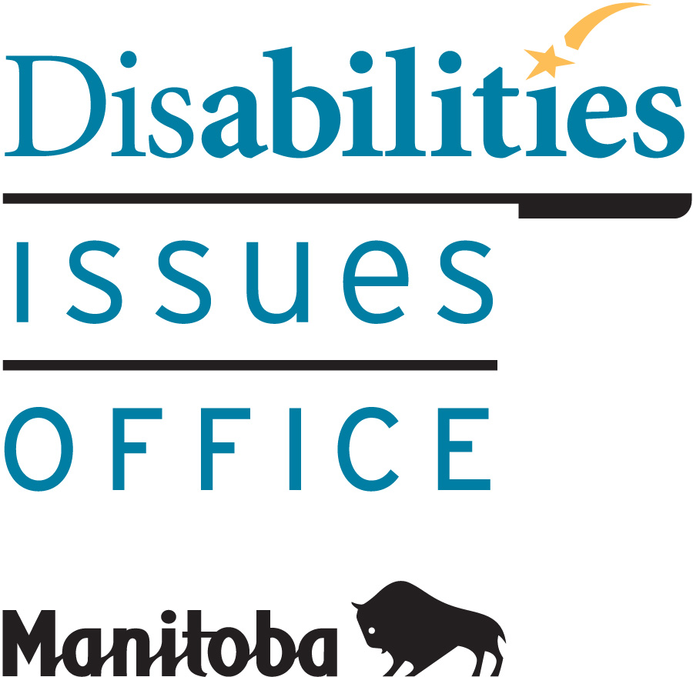
Room 630 – 240 Graham Avenue
Winnipeg MB R3C 0J7
Phone: 204-945-7613 / Fax: 204- 948-2896
Toll Free: 1-800-282-8069, Ext. 7613

December 9, 2016

Greetings,

On behalf of the Accessibility Advisory Council, established by the Government of Manitoba to advise and make recommendations regarding The Accessibility for Manitobans Act (AMA), the DIO invites your feedback on the draft Accessibility Standard on Employment.

The AMA was enacted in 2013 to identify, prevent and remove barriers that affect Manitobans in their daily lives. The legislation calls for the development of standards to regulate what public and private organizations must do, and by when, to achieve accessibility. The first of five standards in the area of Customer Service was enacted in November 1, 2015. It will affect all organizations with at least one employee by November 1, 2018. Employment is the next area for standard development.

Consultation is critical to the standard development process. The Initial Proposed Accessibility Standard on Employment is intended to be a starting point to receive feedback from persons with disabilities, organizations with a responsibility to eliminate barriers and the general public. Please participate by sending your comments and submissions to: access@gov.mb.ca. You are invited also to participate in a public consultation on:
Wednesday, January 18, 2017
(Webcast and In-Person)
1:00 to 4:00 p.m.
(Registration at 12:30 p.m.)

Viscount Gort Hotel
Main Floor, Royal ABC Ballroom
1670 Portage Avenue
Winnipeg, Manitoba

-2-

To register, please complete the attached Registration Form and send by e-mail to: Tracy.MacMillan@gov.mb.ca or call the Disabilities Issues Office at (204) 945-7613 or toll-free at 1-800-282-8069, Ext. 7613. Sign language interpretation, real time captioning and personal care attendants will be on-site, and please help us create a scent-free environment. The deadline for registration is Monday, January 9, 2017.

If you are unable to attend in person, please join us by webcast. The related documentation is available on the website: www.AccessibilityMB.ca
Registration for the webcast will begin online on January 6, 2017.

Please let us know if you require other disability accommodations to participate in this consultation. Please contact the DIO for information about a future consultation in French.

Thank you in advance for your contribution to these important discussions on how to make Manitoba more accessible for everyone.

Yours sincerely,

Yutta Fricke

Yutta Fricke
Executive Director

Attachment

