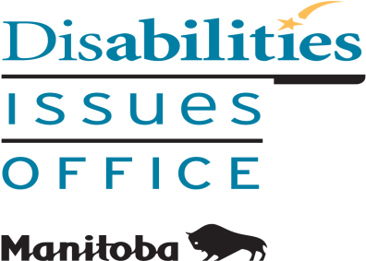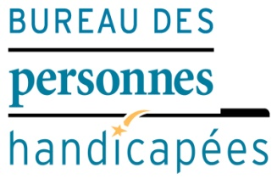

How Accessibility Legislation
Affects You

You are invited to learn about
The Accessibility for Manitobans Act (AMA) and
The Accessibility Standard for Customer Service

This 2-hour session will help private and public sector organizations comply with the AMA.
See also: www.AccessibilityMB.ca

Admission is free; registration is required.
(Registration Form included)

Please check (√) any disability accommodations that you may require:

□ Braille | □ Computerized Note Taker
□ Large Print | □ Food Allergies
□ Sign Language Interpreter | □ Language
□ Personal Care Attendant | □ Other ________________

REGISTRATION FORM

Accessibility Plan Training Workshops

Please check (√) the day you would like to attend:

Location: Main Floor, United Way, 580 Main Street, Winnipeg MB

Thursday, Jan. 11, 2018 Wednesday, Feb. 14, 2018

Time: 1:00 to 3:00 pm Time: 1:00 to 3:00 pm

Wednesday, March 7, 2018 Thursday, March 29, 2018

Time: 1:00 to 3:00 pm Time: 1:00 to 3:00 pm

There will be a lifestyle break with light refreshments

Name of Participant: _____________________________________________________________

Name of Organization: _____________________________________________________________

Address: _____________________________________________

_____________________________________________

Phone Number: _______________ Fax Number: _____________________

E-mail Address: _______________________________________________

TO REGISTER or For More Information Contact:

Tracy MacMillan, Office Manager
E-mail: Tracy.MacMillan@gov.mb.ca
Phone: (204) 945-7613 / Fax: (204) 948-2896

Manitoba Disabilities Issues Office
Room 630 – 240 Graham Avenue
Winnipeg MB R3C 0J7

REGISTRATION DEADLINE IS: A week before each workshop.

PLEASE E-MAIL, FAX OR MAILTHIS COMPLETED FORM BACK

