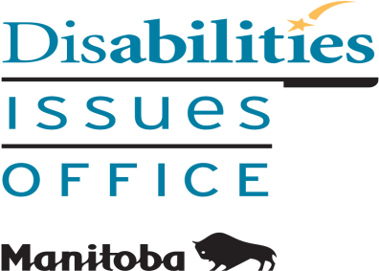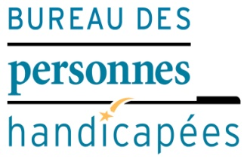

Organizational Requirements
of the Customer Service Standard

You are invited to learn about
The Accessibility for Manitobans Act (AMA) and
The Accessibility Standard for Customer Service

This 2-hour training session will help private and public sector organizations comply with the AMA.
See also: www.AccessibilityMB.ca

Admission is free; registration is required.
(Registration form is on page 2)

Please check (√) any disability accommodations that you may require:

□ Braille | □ Computerized Note Taker
□ Large Print | □ Food Allergies
□ Sign Language Interpreter | □ Language
□ Personal Care Attendant | □ Other ________________

REGISTRATION FORM

Organizational Requirements of the Customer Service Standard
Training Sessions

Please check (√) the day you would like to attend:

Location: Main Floor, United Way Office, 580 Main Street in Winnipeg

Friday, April 5, 2019 Thursday, May 16, 2019

Time: 1:00 to 3:00 pm Time: 1:00 to 3:00 pm

Wednesday, June 12, 2019

Time: 1:00 to 3:00 pm

Name of Participant: ______________________________________________

Name of Organization: ____________________________________________

Address: _______________________________________________

_______________________________________________

Phone Number: _________________ Fax Number: _____________________

E-mail Address: _________________________________________________

Please Identify If You Are:

Non-Profit Organization: ______ A Private Sector Organization: ______

Other Type of Organization: _____________________________________

TO REGISTER, PLEASE E-MAIL, FAX OR MAIL THIS COMPLETED FORM BACK TO:

Tracy MacMillan, Office Manager
Manitoba Disabilities Issues Office
Room 630 – 240 Graham Avenue
Winnipeg MB R3C 0J7
E-mail: Tracy.MacMillan@gov.mb.ca
Phone: (204) 945-7613 / Fax: (204) 948-2896

Registration deadline is a week prior to each training session.

Please know that this is a scent-free environment.

