Employer’s Handbook on the Accessibility Standard for Employment
  - For Businesses and Non-Profit Organizations

The Accessibility for Manitobans Act

Version 2.0
Updated February 2021
Table of Contents
Introduction 3
Who must comply with the Accessible Employment Standard? 3
Safety comes first! 4
Other requirements 4
Why accessible employment matters 5
Barriers to employment 6
Reasonable accommodations in the workplace 8
Pre-employment accessibility requirements 9
1. Remove barriers to recruitment and selection. 9
➢ Recruitment 9
➢ Selection 9
2. Mention workplace accommodations in your offer. 11
Employment accessibility requirements 12
3. Inform employees about accommodation policies and practices. 12
4. Communicate in a way that meets employees’ needs. 13
5. Create individualized accommodation plans for employees that request them. 13
6. Consider accommodations in performance management. 14
7. Consider accommodations in career development, training, internal advancement or reassignment. 15
8. Return to work. 16
9. Keep employees with disabilities safe during emergencies. 17
10. Maintain employee privacy. 18
11. Training. 19
12. Keep a written record. 20

Introduction
On May 1, 2019 the Manitoba government passed the Accessible Employment Standard Regulation under The Accessibility for Manitobans Act. The regulation builds on the Manitoba Human Rights Code by setting requirements for Manitoba employers to remove barriers at all stages of employment.
The purpose of this handbook is to help employers develop practices to meet requirements under the Accessibility Standard for Employment. Employers are welcome to use other practices that are not required by law, but would help to make workplaces more accessible.
Manitoba employers with 50 or more employees are required to document their accessible employment policies. Manitoba employers with 49 or fewer employees are not required to document their accessible employment policies or to establish individualized accommodation policies. Nonetheless, it is a good idea to do so and can greatly assist organizations with training, information sharing, future planning and decision-making.
This handbook is complemented by several other guides and templates, including:
- Accessible Employment Standard Policy Guide and Template
- Workplace Emergency Response Information Toolkit (PDF) (Word)
- Guide to Create an Individualized Accommodation Plan Process and Policy – for Public Sector Organizations (PDF) (Word)
- Discussing Accessibility in the Workplace poster (PDF) (Word)
- Barriers and Solutions in the Workplace
- Frequently Asked Questions
Learn more at AccessibilityMB.ca

Who must comply with the Accessible Employment Standard?
The Accessibility Standard for Employment:
- targets any Manitoba business or organization with paid employees who are:
  - full-time
  - part-time
  - apprentices
  - seasonal
- helps all Manitoba organizations hire, support and keep employees
Under the standard, different types of organizations are given different timelines to meet their legal requirements. The following chart summarizes the requirements and timelines.
Requirements | Manitoba Government | Public Sector/ Large Municipalities | Private Sector/ Small Municipalities
Workplace Emergency Response Information | May 1, 2020 | May 1, 2020 | May 1, 2020
All Other Requirements | May 2020 | May 2021 | May 2022

Safety comes first!
Effective May 1, 2020, the Accessibility Standard for Employment requires all employers in the public, private and non-profit sectors to offer:
- Workplace Emergency Response Information to help employees with disabilities stay safe during emergencies.
- Workplace Emergency Assistance to ensure employees who require assistance during an emergency give their permission to share information with individuals who agree to help.

Other requirements
The Manitoba government is demonstrating leadership by complying with the full standard effective May 2020.
Public sector organizations must comply with the full standard by May 2021. These organizations include:
- Crown corporations
- regional health authorities
- colleges
- universities
- school divisions
- Manitoba’s 10 largest municipalities and government agencies.
The private sector, non-profit organizations and small municipalities must comply with the full standard by May 2022. The private sector includes Manitoba businesses and organizations with one or more employees, such as:
- shops
- restaurants
- professional services
Non-profit organizations include:
- charities
- places of worship
- community organizations
- membership associations

Why accessible employment matters
Manitobans with disabilities want to work, and Manitoba employers want the best employees possible.
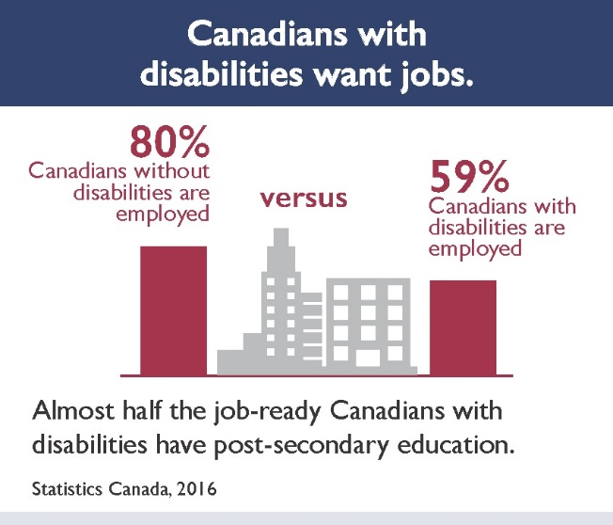
Research shows that it’s good business to employ Manitobans with disabilities, for a number of reasons:
- Talent: By creating accessibility in hiring and on-the-job, workplace diversity encourages innovation and dedication of all staff. Accessibility also ensures employees perform at their best.
- Reliability: When appropriately accommodated, research shows low absenteeism, turnover and fewer workplace accidents among employees with disabilities.
- Reputation: Studies show employees and customers are more loyal to businesses that show they value diversity.

Barriers to employment
Many people think that disabilities are barriers. This is not the case. The Accessibility for Manitobans Act defines a barrier as anything that interacts with a disability in a way that affects a person’s participation in everyday life.
Types of barriers | Workplace examples
Attitudinal barriers result in prejudice or misunderstanding that limit participation and opportunities. | - Fellow employees wrongly assume that because their colleague has difficulty speaking, he also has difficulty thinking.
Information and communication barriers prevent people from easily accessing information. | - Emergency evacuation information is posted on the wall, but not available electronically for people who cannot see the poster.
Architectural or environmental barriers are features of buildings or spaces that limit access for people with disabilities. | - Cluttered office hallways create hazards for people with low vision, walkers, wheelchairs or service animals.  - Use of chemicals in glue and perfumes causes headaches.
Technological barriers occur when not everyone can access a message or service because the device is not accessible or the user has not considered accessibility features (for instance, on a computer). | - Employees must key in their codes to enter the office on a touch screen with numbers that cannot be accessed by people with vision disabilities (unlike a button pad).
Systemic barriers are policies, practices or procedures that discriminate against people with disabilities. | - Retail floor staff are expected to be on their feet the entire shift, without the opportunity to sit, even if the employee has hip pain.  - An employer will not allow employees to modify a work schedule to accommodate medical appointments.
Tip: Some barriers, like attitude, affect the office culture and require leadership from management, as well as training and open discussion. Visit MB.211.ca, and select People with Disabilities for a list of Manitoba non-profit organizations that offer accessibility training and consultation.

Reasonable accommodations in the workplace
Accommodations are tools and strategies that break down barriers and allow employees with disabilities to do their jobs. The Accessibility Standard for Employment requires employers to provide reasonable accommodations for people with disabilities.
Based on The Human Rights Code (Manitoba), a workplace accommodation is reasonable if:
- it is required for an employee to carry out workplace responsibilities or to access employee benefits; and,
- it would not result in undue hardship, such as safety risks to other staff or a significant measurable financial burden.
Reasonable accommodation levels the playing field for employees with disabilities, so they can equally access opportunities available to others in the workplace. The accommodation process is based on the responsibility, shared by the employer and the employee, to have meaningful dialogue about accommodation, and work together respectfully towards accommodation solutions.
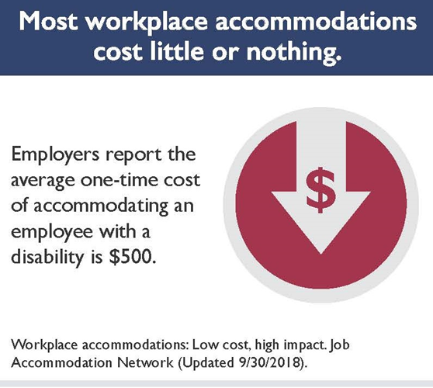
Accommodations are typically made for all staff, even though they may not be called that. For example, a flexible work schedule may be an accommodation for someone with insomnia who arrives and departs an hour later. The same flexibility may be requested by parents to organize work around daycare, or to work from home when their children are ill.

Pre-employment accessibility requirements

Remove barriers to recruitment and selection.

Recruitment
What you need to do:
Inform applicants that the organization will respond to requests for reasonable accommodation during the selection process.
Sample Job Ad Wording
[Name of Organization] welcomes applications from people with disabilities. Accommodations are available upon request during the assessment and selection process.
Or: Disability accommodations available upon request.
Tips:
- Do not create pre-interview requirements that are not necessary to perform the job. For example, do not require applicants to have a driver’s license, when they could use other transportation to carry out their job. Consider what is actually required to perform the job.
- Advertise the job to employment agencies that serve people with disabilities. Many agencies provide support to assist you and the new employee during the recruitment process.

Selection
What you need to do:
- Tell candidates that accommodations for the assessment process are available on request, whether for an interview, written test, or on-the-job skills demonstration.
- When applicants make a request, consult with them about what types of accommodations would work best.
Tips:
- Use standardized interview scripts, questions and scoring to avoid bias among candidates in the interview process.
- Never assume what a candidate can or cannot do. For example, if a position requires a driver’s license, do not assume that a candidate who uses a wheelchair is unable to drive.

Checklist for an Accessible Interview:
- Choose an accessible location, with level entry or elevators, and provide assistance if requested.
Example: An applicant with a visual impairment requires assistance finding the interview location. The interviewer and candidate agree to meet in the lobby to proceed to the interview location together.
- Set up the interview room in an accessible way.
Example: The employer chooses an interview room that is brightly lit and quiet. This minimizes distractions for all candidates and is especially helpful for individuals who may have some hearing loss or are anxious.
- Allow support persons to accompany a candidate to the interview.
Example: A support person, or family member, of a person with a disability guides the candidate to the interview location, sets up preferences on the computer before a test, or calms someone who is affected by anxiety.
- Create tests or skill assessments that accommodate all candidates.
Example: The employer ensures typed instructions to candidates are understandable by reviewing the text for clarity, providing large font on paper instructions and offering electronic testing. The employer offers additional time for candidates with disabilities, if required, and supplements the written portion of the assessment with a half-day job performance trial.
- Demonstrate diversity on the interview team.
Example: When the employer learns that one of the candidates has a communication disability, the employer invites another staff member with related expertise to join the interview team.

Mention workplace accommodations in your offer.

What you need to do:
When you make an offer of employment, inform the individual about the organization’s policies and practices regarding workplace accommodations.
Tip: When someone asks for an accommodation in the workplace, acknowledge that the person is demonstrating trust and courage. Many employees who could benefit from an accommodation may fear that disclosing a disability will have a negative impact on their career.
Sample Wording
[Name of Organization] provides workplace accommodations for employees with disabilities or medical needs. If you require an accommodation because of a disability or a medical need, please contact [Company Representative, Title] at [Telephone number] or by e-mail at [Email].
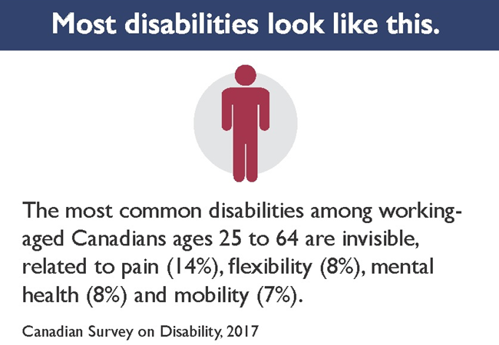

Employment accessibility requirements

Inform employees about accommodation policies and practices.

What you need to do:
Inform all employees about your organization’s policies and practices related to workplace accommodation and provide updates on any changes.

Sample Wording
[Name of Organization] provides workplace accommodations for employees with temporary or permanent disabilities. Disabilities can be visible or invisible. If you require an accommodation because of a disability, please contact [Company Representative, Title] at [Telephone number] or by e-mail at [Email].
Tips:
- Include information about workplace accommodations in orientation materials.
- Print and post in the staff area the one-page information sheet called Discussing Accessibility in the Workplace: (PDF) (Word).

Communicate in a way that meets employees’ needs.

What you need to do:
Respond to the communication requests of employees with disabilities by:
- consulting with them to identify the accessible format or communication support that meets their needs
- using this format and communication support when providing them information
Accessible formats may require modification of the original document to meet the needs of an employee with a disability. Options may include printing the document in a larger font or sending the document electronically, so the employee can use voice software to hear what is written.
Communication supports may include providing verbal information in writing, for example, for someone who is hard-of-hearing or who has memory loss.
Tips:
- Develop policies in plain language, so everyone understands them.
- Use a variety of communication methods to inform staff, such as a poster at the water cooler, an all-staff email, or a Lunch and Learn session.

Create individualized accommodation plans for employees that request them.

What you need to do:
- Respond to requests from employees with disabilities to develop and implement an individualized accommodation plan. Management may also suggest a plan to an employee or ask if they require workplace accommodations.
- The individualized accommodation plan must document actions used to provide the employee with details about:
- accessible formats or communication supports that will be used to provide information to the employee (See 4 above),
- workplace emergency response information (see 6 below),
- how and when workplace accommodations will be provided.
- The employee must cooperate in the assessment of the accommodation by providing information and related evaluations, for instance by a doctor, by complying with the accommodation plan and by providing updates about necessary modifications or when the accommodation is no longer required.
- The employer must set a timeframe for the review of the accommodation plan, and update the plan in case of job, workspace or other related changes, or if requested by the employee.

Employers may request an evaluation of an employee by an independent regulated health professional or other worker in the area of workplace accommodations to help determine whether an accommodation is required. Employers are required to pay for these evaluations.
Public sector organizations and businesses or organizations with 50 or more employees must create an Individualized Accommodation Plan Policy. See resources below.

More resources:
Guide to Create an Individualized Accommodation Plan Process and Policy for Public Sector Organizations: (PDF) (Word), including Sample Policy Template and Sample Individual Accommodation Plan Worksheet.

Consider accommodations in performance management.
Performance management is any process used by an employer to manage the work of individual employees. The purpose may be to monitor and review how well the employee is fulfilling his or her job description, changes to the job, plans for the way forward, or to review the employee’s overall contribution to the organization.
Some, but not all, employers use a formal process for performance management, with pre-scheduled discussions between supervisors and employees and documented next steps.

What you need to do:
- When managing or evaluating the performance of your employees, consider whether a workplace barrier is affecting an employee’s performance, and how an accommodation could remove this barrier.
- If the employee has an individualized accommodation plan in place, a change in performance may mean the plan needs updating. Changes over time to disability or medical needs may require a modification to the accommodation.
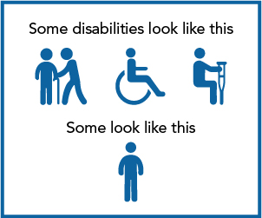
Tips:

Many employees find it difficult to ask for an accommodation, and the reason for the accommodation may be sensitive to the employee. Things you can do as a supervisor:

• Give the employee a safe space to speak and listen to them without judgment.

• Try to understand what the concern is and how you can help.”

- Ensure supervisors’ attitudes reflect the organization’s commitment to disability inclusion, so preconceptions do not affect the evaluation of an employee’s performance.

Consider accommodations in career development, training, internal advancement or reassignment.
Many employers offer opportunities for career development by giving employees increased responsibilities and related training. In some cases, internal recruitment and selection results in promotion. In other cases, during reorganization or downsizing, employers may also be considering reassignment or layoffs.

What you need to do:
- When offering career development and training opportunities to your employees, or in a situation of reorganization and reassignment, consider how accommodations could remove barriers to equalize opportunities for affected employees.
- If an employee currently has a workplace accommodation, consider whether a modification to the accommodation could more effectively address any barriers.
Tips:
- Transfer an employee’s current accommodation plan and supports if they are reassigned to another area. Check if the plan includes medical information. If it does, it requires the employee’s consent before sharing the information.
- When developing or contracting out training programs, consider the accommodation needs of your employees in advance, for example, by telling trainers whether employees require accommodations that affect the training. Sending course material in advance may help.

Return to work.

What you need to do:
- When introducing workplace accommodations to employees who are returning to work following an absence due to a disability, ensure the Workers Compensation Act guides your policies and practices.
- Include in your policies the steps your organization will take to assist the employee in returning to work. For example, who will communicate with the employee, and when will the communication occur?

Overview of the Return to Work Process
  - Step 1: Communicate with the employee on leave.
While the employee is on leave and throughout the return to work process, identify someone as the return to work coordinator to oversee the employee’s transition back to the workplace. Ensure ongoing communication during the leave.
  - Step 2: Determine the employee’s functional abilities.
When planning for an employee’s return to work, confirm the worker’s current abilities. Ask the worker’s health care professional to complete a functional ability form, which emphasizes the employee’s work-related abilities (e.g., noting that the employee can lift up to five pounds).
  - Step 3: Confirm the functional abilities with the Worker’s Compensation Board, where applicable.
When the functional ability form is complete, the employer must confirm work abilities with the Worker’s Compensation Board of Manitoba (WCB), which will receive the injured worker’s medical reports from healthcare providers, including diagnosis and prior injuries and illnesses. Copies of these reports are not sent to employers.
  - Step 4: Implement and document the return to work plan.
Using the results from the abilities assessment, determine how the employee can best return to work.
More resources: Contact the Worker’s Compensation Board of Manitoba.

Keep employees with disabilities safe during emergencies.
Even employees who do not require accommodations to do their jobs may need help during an emergency. For example:
- Someone with asthma or with a weak immune system may be especially vulnerable to a pandemic, like COVID-19.
- An employee with a heart condition may not be able to descend six flights of stairs.
- An individual with Post Traumatic Stress Disorder (PTSD) may freeze at the sound of an alarm.
Ensure your workplace emergency response procedures allow employees to self-identify whether they need assistance in a workplace emergency.

What you need to do:
- Make individual emergency response information available for employees with disabilities.
- Ask employees who require assistance during an emergency for permission to share information with individuals who have agreed to help.

More resources:
For a step-by-step guide for providing emergency response information, please see the Workplace Emergency Response Information Toolkit. This toolkit is also found at AccessibilityMB.ca and includes:
- a sample memo to all employees asking if they require assistance in an emergency
- a sample Employee Emergency Information Worksheet
- a sample Employee Emergency Response Information Template
- consent to share emergency response information

Maintain employee privacy.

What you need to do
Protect employees’ personal information and personal health information by:
- Only collecting, using or disclosing this information as required to meet the Accessibility Standard for Employment (e.g., in providing reasonable accommodation).
- Requesting the consent of affected employees to use or disclose this information for other purposes, for example, to publicize your organization’s accommodation practices.

Tips:
- Limit access to employee information to managers or others working in human resources.
- If possible, lock employee information in a filing cabinet.

More Resources:
The Freedom of Information and Protection of Privacy Act (Manitoba)
The Personal Health Information Act (Manitoba)

Training.

What you need to do:
- The Accessible Employment Standard requires that training about disability accommodations is provided to all employees who:
- recruit, select or train other employees
- manage, supervise, or coordinate other employees
- promote, redeploy or terminate other employees
- develop and implement employment policies and practices
- Accommodation training must include how to:
- make employment opportunities accessible to persons with disabilities
- communicate with people disabled by barriers
- interact with individuals who use an assistive device, such as a hearing aid, wheelchair or walker, or who have a support person or service animal.
Training must also include a review of The Human Rights Code (Manitoba), The Accessibility for Manitobans Act and the Accessible Employment Standard.
- Training must take place as soon as practical when employees take on the roles listed above (A), and must be updated as related policies and practices change.
- Large employers with 50 or more employees must create and document an accommodation training policy, including a summary of the content and when training is to be provided.
Tip: With their consent, include the experiences of employees with disabilities in your training program, or visit MB.211.ca and select People with Disabilities for a list of Manitoba non-profit organizations that offer accessibility training and consultation.

More resources:
AccessibilityMB.ca/training
Workers Compensation Board of Manitoba (WCB)
SAFE Work Manitoba

Keep a written record.
Large organizations with 50 or more employees must keep a written record. Smaller organizations with 49 or fewer employees may choose to keep a written record to assist with training, information sharing, future planning and decision-making.

What you need to do:
- Keep a written record of accessible employment policies and practices, including a summary of training content and when training is offered.
- Have a policy on individualized accommodation plans that meets the requirements of section 13(2) of the Accessible Employment Standard Regulation.
- Let the public know that accessible employment policies and practices are available on request and in accessible formats.
Tip: Write your policies in plain language, so that everyone understands them.
Tip for public sector organizations: To meet your organizational requirements under The Accessibility for Manitobans Act, add an accessibility page to your website, where the public can view accessibility plans, policies and practices.

More resources:
Accessible Employment Standard Policy Guide and Template

For more information, visit AccessibilityMB.ca or contact:

Manitoba Accessibility Office (MAO)
630 - 240 Graham Avenue
Winnipeg MB R3C 0J7
Phone: 204-945-7613 (in Winnipeg)
Toll-Free: 1-800-282-8069, Ext. 7613 (outside Winnipeg)
Fax: 204-948-2896
Email: mao@gov.mb.ca

This document is available in alternate formats, upon request.
The Manitoba Accessibility Office thanks the Queen’s Printer, Ontario for allowing the adaptation of their resource material for this document.

Legal disclaimer: This information complements the application of the regulations under The Accessibility for Manitobans Act (AMA) and is not legal advice. For certainty, please refer to the AMA and the Accessible Employment Standard Regulation.

Version 2.0
Updated: February 2021

