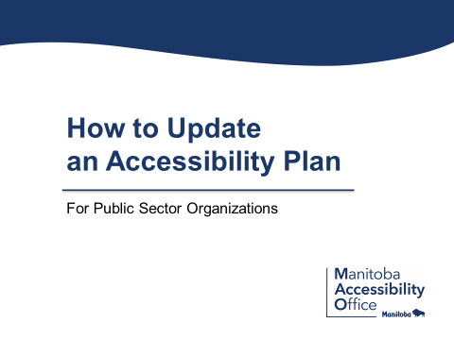

Speaker: Lucia Madariaga-Vignudo (Accessibility Compliance Secretariat, Government of Manitoba)

Timestamps
00:09 – Disclaimer
00:23 – Why this presentation is developed?
00:42 – Alternate formats upon request
01:30 – The Accessibility for Manitobans Act
02:19 – What is an Accessibility Plan?
03:30 – Did you know…
03:57 – Important
04:12 – Why should your organization update your accessibility plan?
04:53 – Steps for updating accessibility plan
05:42 – Accessibility plan tips
07:04 – Resources and Contact Information
08:12 – Thank you
08:34 – Remember to submit
08:55 – End of presentation

[Presentation Begins]

Disclaimer: ASL interpretation for the following content was presented live and was not pre recorded.

Hello, this brief presentation has been developed to assist public sector organizations in Manitoba to comply with a requirement to update their accessibility plants.

Alternate formats upon request. This information is available in alternate formats on request, please contact the Manitoba accessibility office by email at mao@gov.mb.ca. Or by phone at two zero four nine four five seven six one three. You can also contact toll free at 1 800 2 8 2 8 0 6 9. Extension 76 1 3. Or visit accessibilityMB.ca.

The accessibility for Manitoban’s act. Accessibility legislation is important to have in place because nearly one in four Manitobans face barriers to accessibility in daily living and with an aging population, this number continues to grow. All Manitobans regardless of their abilities, have the right to participate fully in society and to be treated with dignity and respect.

And with the introduction of accessibility legislation, organizations must all collaborate to make Manitoba accessible.

Well, what is an accessibility plan? An accessibility plan is a written document that is required to be developed by all public sector organizations under the accessibility for Manitoban’s act. This includes small and large municipalities, crown corporations, regional health authorities, post-secondary institutions, school divisions, and the government of Manitoba. An accessibility plan outlines measures your organization has taken and will take to identify, remove, and reduce barriers to accessibility.

The document lists the measures in place to ensure your organization assess its policies, programs, practices, services, rules, or bylaws to determine their impact on accessibility. While accessibility plans can have an internal audience, they must be made available to the public.

Did you know that 87% or 165 out of 189 public sector organizations across Manitoba have created an accessibility plan. This is encouraging and worth celebrating as it is showing a commitment towards accessibility by many organizations.

Important. Accessibility plans must be updated every two years per the accessibility for Manitoban’s act.

Why should your organization update your accessibility plan? We'll updates to accessibility plants are needed because they help focus an organization to consider and eliminate new barriers. Updates also ensure that all Manitobans have full access to programs and services designed to meet their needs and updates are required by law and failure to do so may lead to compliance and enforcement activities.

Steps for updating your accessibility plan. Begin by reading through your current accessibility plan and then reviewing progress on any policies, actions, or measures your organization has taken to create accessibility in the past two years. Set future priorities, including compliance with requirements under accessibility standards and identify the actions your organization will take to advance accessibility in the next two years.

Lastly, make your updated accessibility plan publicly available.

Accessibility plan tips. It is helpful to include the following in your accessibility plans, a contact person with ways to get in touch by email or phone number, the time period the plan covers how your organization meets or exceeds accessibility standard requirements.

Accessibility plan tips continued. Prioritize accessibility when discussing corporate and strategic planning and integrate your accessibility plan into quarterly or annual reporting periods and or board meetings. You may choose to update your accessibility plan by editing the original plan that acts as a baseline, or you can use the free template titled “how to update your accessibility plan” available at accessibility B.ca.

Organizations can copy and paste from this template and adapt it to meet their needs.

Resources and contact information. For more information and accessibility plan resources, including sample plans developed by organizations, visit accessibilityMB.ca. For accessibility plan requirements and information related to compliance, contact the accessibility compliance secretariat at accessibilitycompliance@gov.mb.ca or at 2 0 4 7 9 2 0 2 6 3.

For all other information, contact the Manitoba accessibility office at mao@gov.mb.ca or at 2 0 4 9 4 5 7 6 1 3 or toll free at 1 800 2 8 2 8 0 6 9. Extension 7 6 1 3.

Thank you. Accessibility is good for everyone, it's the law in Manitoba. So let's collectively recognize accessibility achievements in our province and prioritize accessibility plans to ensure an accessible Manitoba.

Remember submit your updated accessibility plan to accessibility compliance secretariat by email at accessibilitycompliance@gov.mb.ca.
[End of Presentation]

