MAO Reminder List –

Creating Accessible Word Documents

October 2022

This information is available in alternate formats on request. Please contact the Manitoba Accessibility Office at MAO@gov.mb.ca or 204-945-7613 or toll free at 1-800-282-8069, ext. 7613.

Introduction
This document is a reminder list of things to do to ensure that your Word document is accessible for people with disabilities.

REMEMBER TO…

- Follow the tips in the MAO document “Tips for Creating Accessible Word Document”.

- Complete an accessibility check using the Accessibility Checker. In Word, Excel, and PowerPoint, select Review > Check Accessibility, or type accessibility into the “Tell me what you want to do…” box.

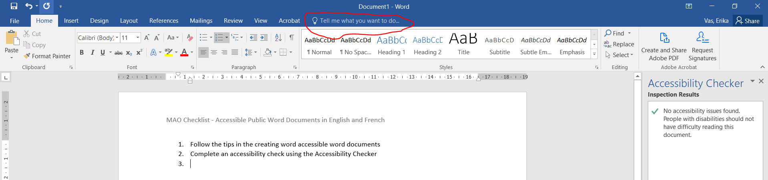
This image shows a red circle around the bar with the words “Tell me what you want to do…” Select Accessibility Checker.

- All graphs and figures must have Captions. To do this, select the graph or figure, right click and select “Captions”.

- All images – anything you insert into a word document, regardless of whether it is clipart, photos, images, etc., must have Alt Text. To do this, select the image, right click and select “Format Picture”. Then click Layout and Properties, the third icon in the horizontal list of icons, the image of a square, next to the photo icon. Input a title and Alt Text.

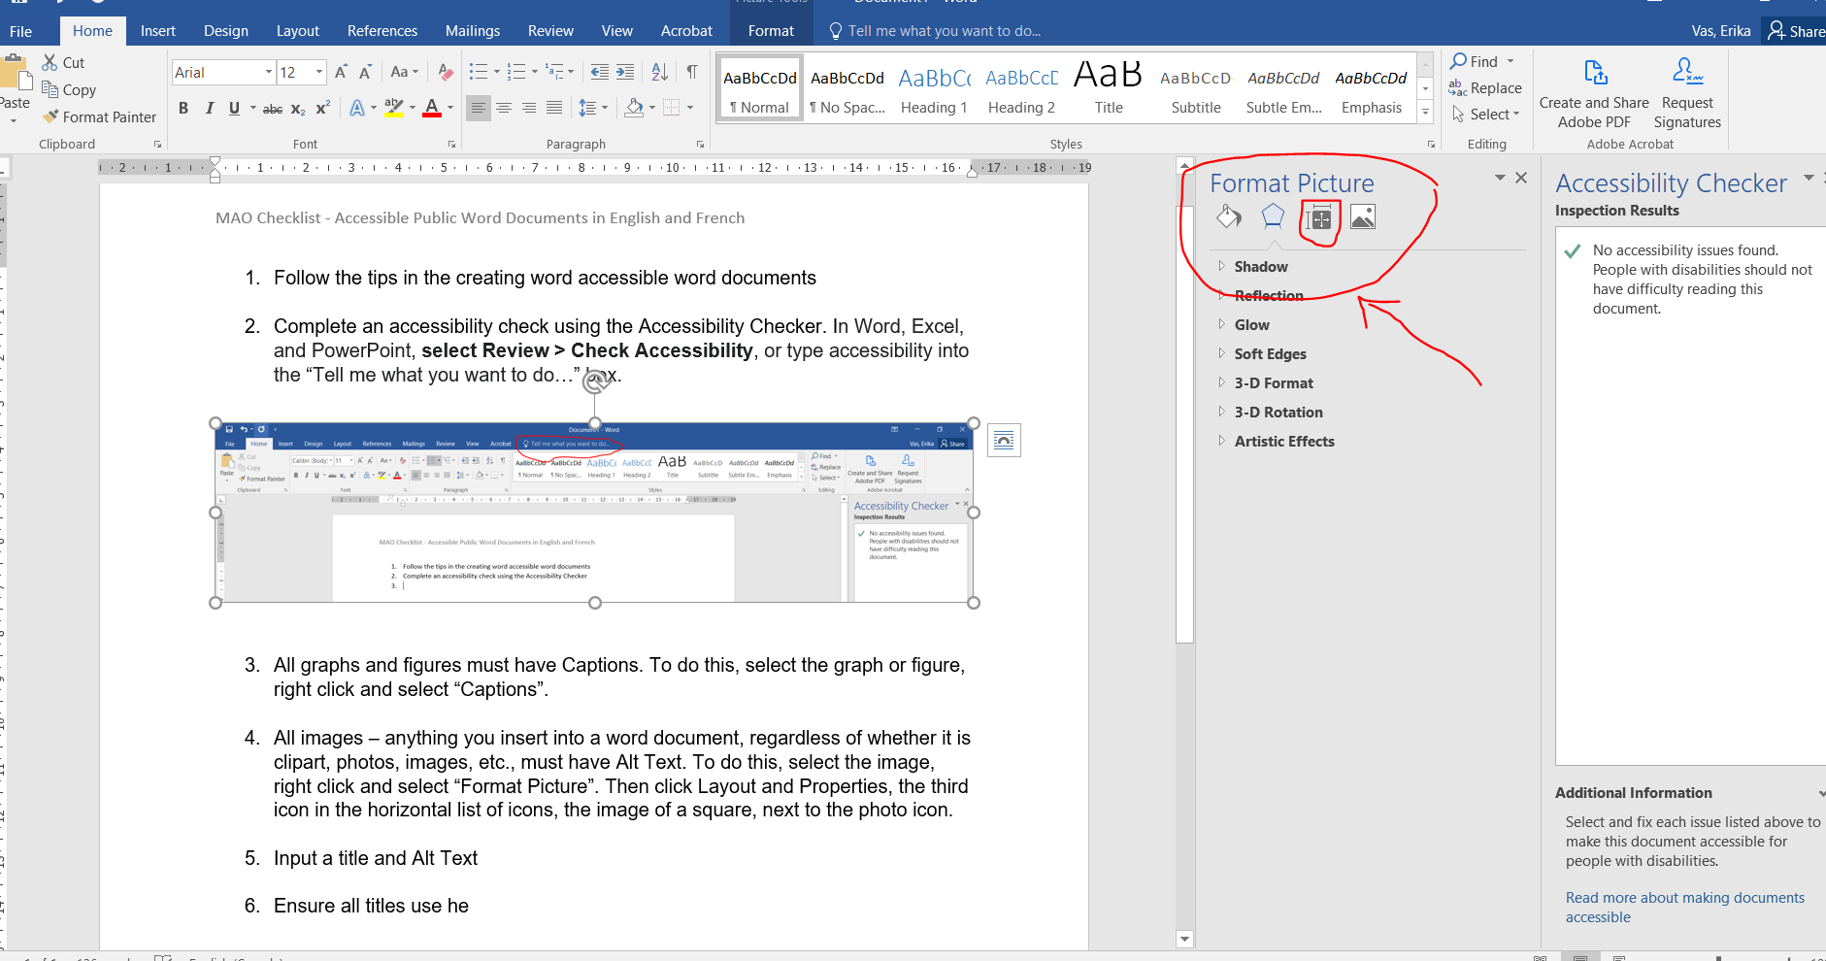
This image shows a red circle around a side menu titled Format Picture with an image of a square also circled in red font to indicate to select this option. There is a red arrow to identify this content on the page.

- Once your English document meets accessibility requirements, prepare and submit an “Alt Text French Translation” document in Word.

- The “Alt Text French Translation” document is simply a Table with 3 columns.

  - Column 1 is titled “Image” that has the image or graph, or logo you would like to be translated.
  - Column 2 is titled “English text” and has any words that are part of the image itself to be translated to French, as well as a description of the image to provide for the ALT text.
  - Column 3 is titled “French text” and will include the translation of the text that is part of the image as well as the description of the image as ALT text.

- It is advisable for the requestor to complete the first two columns in the form, that is, the image and all English text to be translated, including the Title and Alt Text, and leave the French column empty.

- When the French translation request is submitted, remember to include your original source document in Word format as well as the “Alt Text French Translation” document with the table to be completed by French Translation Services.
Please Note: graphs and figures should also be included in this document. Take a screen capture of the graph or figure, and in the English column, include the text from the caption, as well as any other information that needs translation.

Example 1:

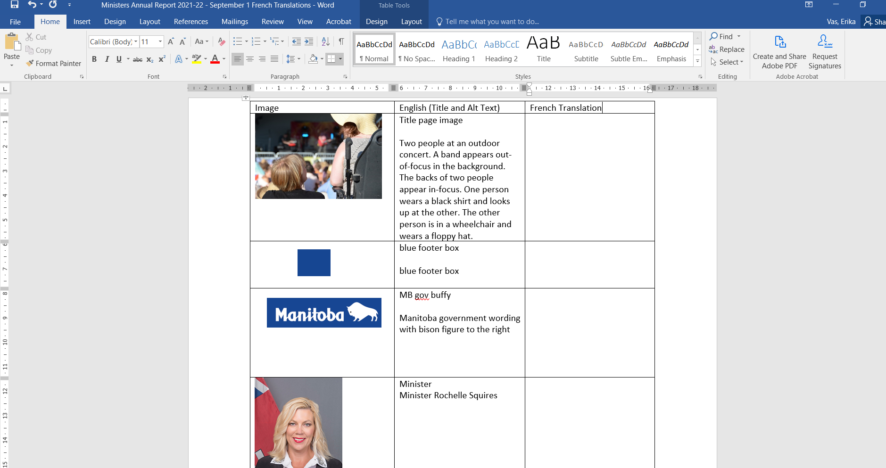
This image shows a screen capture of a table with an image in the first column, the English text in the second column, and third column to add in the text that has been translated to French.

Example 2:
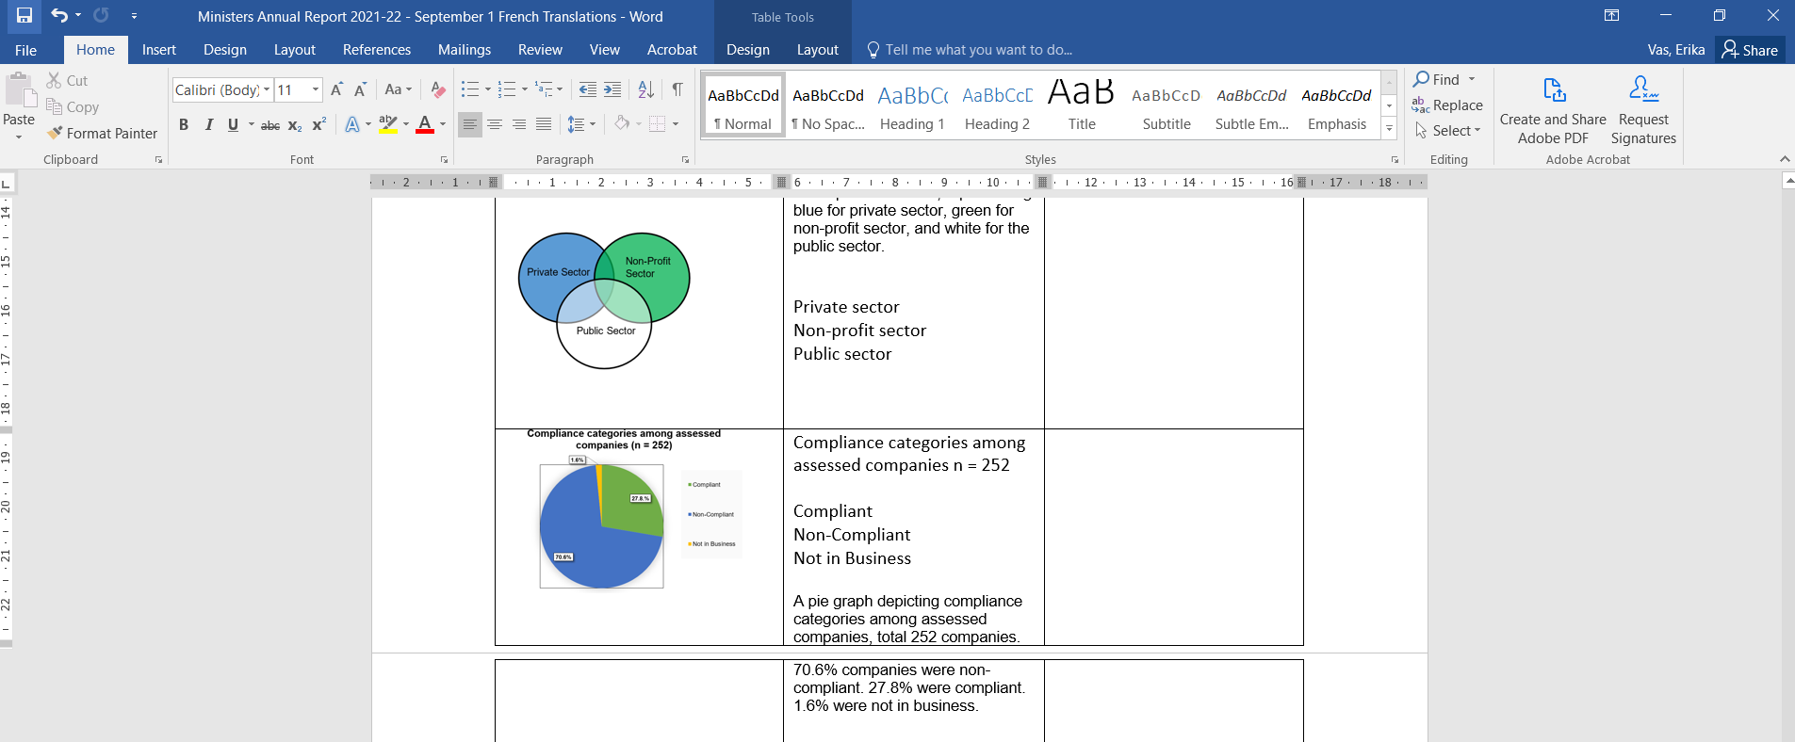
This image shows a screen capture of a table with an image of 3 circles (Venn diagram) in the first column, then columns for English text and French text.

- Once you have the French translations, ensure all graphs, figures, and images in the document have French captions or alt text.

Contact Information
If you have any questions or require this information in an alternate format, please contact the Manitoba Accessibility Office.

Manitoba Accessibility Office
630 - 240 Graham Avenue
Winnipeg MB R3C 0J7
Phone: 204-945-7613; Toll-free: 1-800-282-8069, Ext. 7613
Email: MAO@gov.mb.ca
Website: AccessibilityMB.ca

For questions about compliance, please contact:

Accessibility Compliance Secretariat
Second Floor – 114 Garry Street
Winnipeg, MB R3C 1G1
Phone: 204-792-0263
Email: accessibilitycompliance@gov.mb.ca

