How to Create an Accessible Word Document

October 2022

This information is available in alternate formats on request. Please contact the Manitoba Accessibility Office at MAO@gov.mb.ca or 204-945-7613 or toll free at 1-800-282-8069, ext. 7613.

Introduction
Making a Word document accessible helps people with visual impairments or cognitive disabilities and is used to create accessible web pages and PDF’s. Despite recent technological improvements, creating an accessible Word document is not a straightforward process, but there are some basic steps to help maximize the accessibility of your Word document.

Features that Make a Word Document More Accessible

Headings

A hierarchical heading structure is an important accessibility consideration for people that use screen readers and other assistive technologies. With a proper heading structure, they can navigate a document by `jumping` through headings. Proper headings are also helpful for sighted users as a document can be quickly scanned. See below for an example of a hierarchical structure:
Heading 1 – used as a chapter heading.
Heading 2 – used as a major sub-section heading.
Heading 3 – used as a sub-section Heading 2.
Heading 4 – used as a sub-section under a Heading 3.
Use Word`s heading structure found under the Home tab to create a proper heading structure. If you want to modify the heading style, follow the instructions below.

Choosing a heading style

There are a couple of different ways to modify a style:
- In the Home tab, you can right click on the heading you want to modify and select Modify. The Modify Style window opens.
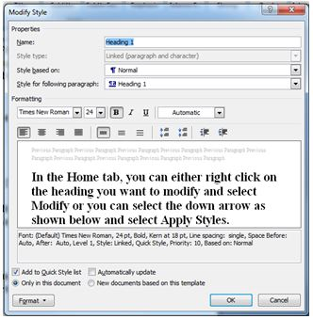
  - Select your styles and select OK
OR,
- Select the down arrow as shown below and select Apply Styles.

  - The Apply Styles window opens. From this window, you can control and manage multiple styles.
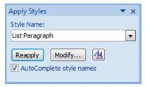
  - From the drop-down, select the style you would like to change. The Modify Style window opens.
  - Select your styles and select OK
To apply a style, select your text and click on style name. To select text with a keyboard, place cursor at beginning of text, press and hold Ctrl+Shift and Right or Left Arrow to end of the text to highlight.
It`s important to not create a "heading" by changing the text and applying a different font type, a larger font size, bold formatting, etc. These changes will provide a visual structure for some users, but the document will not meet accessibility standards and assistive technology users will not be able to navigate through your document easily.

Alt Text

The alternative attribute (alt text) is used to provide an accurate description of the visual content for people with cognitive and learning disabilities or an aid for people with visual impairments or low vision. The ‘alt’ attribute helps the user learn about the content in a document.

Note: Avoid WordArt and text boxes as they may
be inaccessible or difficult for persons with low vision.

Adding alternative text

If you are using Word 2007, follow these steps:
  - After you have inserted a picture or if you click on the picture you inserted, the Format tab under Picture Tools window opens.
  - Click the arrow in the lower-right corner of the Size group. The Size window will open.
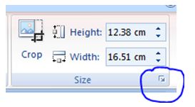
  - Select the Alt Text tab.
  - In the Alternative Text box, type the ALT text, and then select Close.
To learn about the different styles of ALT text, review the Alternative Attributes for Image Descriptions document.
If you are using Word 2013, follow these steps:
  - Right-click the picture that you inserted, then select Format Picture...
  - Select the third icon and then select Alt Text

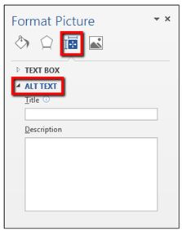
  - Type in the Title and Description boxes, then select Save.
When entering alternate text you will notice there is a Title and Description field. The Title field is a short description and someone using a screen reader can decide to listen to the text provided in the Description field.
3. Lists
Lists add an important hierarchical structure to a document and are easier to read than long paragraphs because they are less intimidating and are usually more direct.
To create an accessible list, use either an ordered or an unordered list in Word. The options are shown in Figure 1:
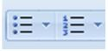
The first option in Figure1 shows an unordered (bullet) list. This type of list is used for a group of items without a sequence:
  - Ketchup
  - Mustard
  - Pickles
  - Onions
The second option, in Figure 1, shows an ordered (numbered) list. This type of list is used to present a group of items (words, phrases, sentences) that follow a sequence:
  - Preheat BBQ on a "high" heat setting.
  - Cook hamburgers on a "medium" heat setting.
  - Flip hamburgers when juices are visible on top of the patty.
  - Remove hamburgers when the inside temperature is 160℉.
It is important to not create lists manually by indenting the content with the Tab button. These changes provide a visual structure for sighted users, but the document will not meet accessibility standards.

Links

Adding a link to your document can be really useful to a user, if done properly. Create a descriptive link that is useful and tells the user where the link takes them.

Creating links in Word
  - Highlight the text you want as the link.
  - Select the Insert tab
  - Select Hyperlink from the Links box. The Insert Hyperlink window will open.

  - Insert the website address in the Address text box near the bottom of the window.
  - Select OK.
It is important to not paste the website address (URL) of a web page into your document. Word automatically creates the link and uses the URL as the display text, but the URL text does not make sense to a user.
For example, the web link would read as http://ww.gov.mb.ca, but should be written as Government of Manitoba. Also avoid using “click here”. Someone using a screen reader can use the Tab button to jump from link to link, but if all of the links say ‘click here’ it is not helpful.

Accessibility Checker

If you are using Word 2007, the Accessibility Checker is not available.
If you are using Word 2013, you can find the Check Accessibility button under the Review tab.
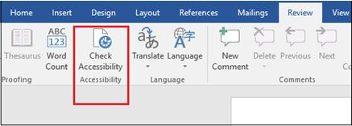

  - The Accessibility Checker task pane appears next to your content and shows the inspection results.
  - To see information on why and how to fix an issue, under Inspection Results, select an issue. Results appear under Additional Information, and you are directed to the inaccessible content in your file.

Inspection Results

The Accessibility Checker identifies possible issues for persons with disabilities. Depending on how severe the issue is, the Accessibility Checker classifies each issue as an Error, Warning, or Tip, which are described as follows:
  - Error. Content that makes the document difficult or impossible for persons with disabilities to read and understand
  - Warning. Content that in most (but not all) cases makes the document difficult to understand for people with disabilities
  - Tip. Content that persons with disabilities can understand but that could be presented in a different way to improve their experience

Converting your document

Website conversion

If your document structure and alternative text has been added correctly, when you submit your document to your departmental web contact, most of the features will be retained. They will be able to effectively convert your content into HTML.

PDF conversion

Converting your document to PDF can be extremely useful when you need to preserve the look of a document. Some documents best suited as a PDF include; brochures, factsheets, annual reports; or application forms (standard or fillable). Unfortunately, because a PDF is a picture of a page of text rather than actual text, PDFs are not inherently accessible to visually impaired people or search engines. Therefore it’s important to create an accessible Word document before converting to PDF.

Tip: To make large documents more user-friendly,
add bookmarks to your PDF. You will need Adobe
Professional to do this.

Tables

The purpose of tables is to present information in columns or rows that show the meaning of the information in the grid. Sighted users scan a table to make associations between data in the table and their appropriate row and/or column headers.
When you have created your table, select Header Row under Table Style Options (shown below). Adding a header row helps a screen reader scan a table in web pages and PDF files. Unfortunately Word documents do not support this functionality.

Inserting a Table Heading
  - Click anywhere in the table.
  - Go to the Design tab at the top of the page.
  - Check the Header Row check box.
  - Type (or retype) your column headings.
  - Press the Enter key

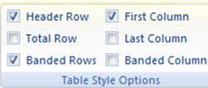

To Insert a Table
  - Click on the Insert tab. The second box from the left in the ribbon is the “Tables” box.
  - Select the table button.
  - Select the number of columns and rows you want and click OK.
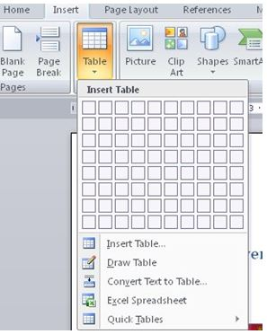

Graphs and Charts

To make Charts and Graphs accessible, add a short caption preceding them that describes their content.
To add a caption:
  - Right click near the edge of the chart, graph or table and choose “Insert Caption”.
  - Word gives you a few default options for your caption. If you’d like to create your own select “New Label” and enter your caption into the pop-up dialog box.
Another option is to provide an alternative presentation of the findings. For many charts, the best alternative format in which to present data is a table with the original figures. Some graphics should include good alternate text but also a text description of the data contained in the image.

Tips for Creating an Accessible Word Document
- Use simple language, write in plain language.
- Ensure that font size is sufficiently large—generally a minimum of 12 points.
- Provide sufficient contrast between text colors and background colors.
- Be careful with the use of watermarks. They can impact readability and create low contrast.
- Provide a table of contents for long documents.
- Avoid WordArt and text boxes as they may be inaccessible or difficult for persons with low vision.
- Create a hierarchical heading structure, use Word`s heading structure and do not create a ‘heading’ by changing the text and applying a different font type, a larger font size, bold formatting, etc.
- Create a hierarchical list structure, use Word`s ordered and unordered list. Do not create lists manually by indenting the content with the Tab button.
Use descriptive links and do not paste the website address (URL) of a web page into your document and avoid using ‘click here’.

Contact Information
If you have any questions or require this information in an alternate format, please contact the Manitoba Accessibility Office.

Manitoba Accessibility Office
630 - 240 Graham Avenue
Winnipeg MB R3C 0J7
Phone: 204-945-7613; Toll-free: 1-800-282-8069, Ext. 7613
Email: MAO@gov.mb.ca
Website: AccessibilityMB.ca

For questions about compliance, please contact:

Accessibility Compliance Secretariat
Second Floor – 114 Garry Street
Winnipeg, MB R3C 1G1
Phone: 204-792-0263
Email: accessibilitycompliance@gov.mb.ca

